ΘΕΜΑ 2β. ΛΕΞΙΚΟΓΡΑΜΜΑΤΙΚΗ
Choose the correct option (A, B or C) for items 21-30.
21. We won’t see Tommy this summer if he …………… to the sports camp.
 | A. | had gone | B. | goes | C. | would go
22. We have …………….. a pay rise by the company manager.
 | A. | been promised | B. | promised | C. | be promised
23. I ………………. talk to her if you don’t want me to do so.
 | A. | would | B. | hadn’t | C. | won’t
24. My parents ………………. to London. They have just called me to say they are having a great time.
 | A. | have been | B. | have gone | C. | go
25. While I ……………… the film, the lights went off.
 | A. | was watching | B. | watched | C. | watch
26. Had I known you were coming, I ………………….. you at the bus station.
 | A. | would meet | B. | will meet | C. | would have met
27. If Jenny ………………….. going on a trip, we would have stayed at home.
 | A. | doesn’t suggest | B. | won’t suggest | C. | hadn’t suggested
28. ………………. I'm concerned, everyone should be given an equal opportunity.
 | A. | As far as | B. | As long as | C. | Although
29. If I ……………….. you, I would pay more attention to their offer.
 | A. | will be | B. | were | C. | be
30. Unless Mark ……………. talking, he will be asked to leave the room.
 | A. | doesn’t stop | B. | stops | C. | will stop

ΘΕΜΑ 3. ΠΑΡΑΓΩΓΗ ΓΡΑΠΤΟΥ ΛΟΓΟΥ
You have come across the following information about the United Nations Volunteers. Write a report (120-150 words) for the English version of your school newspaper explaining the importance of volunteering and what volunteers can gain from such an experience.
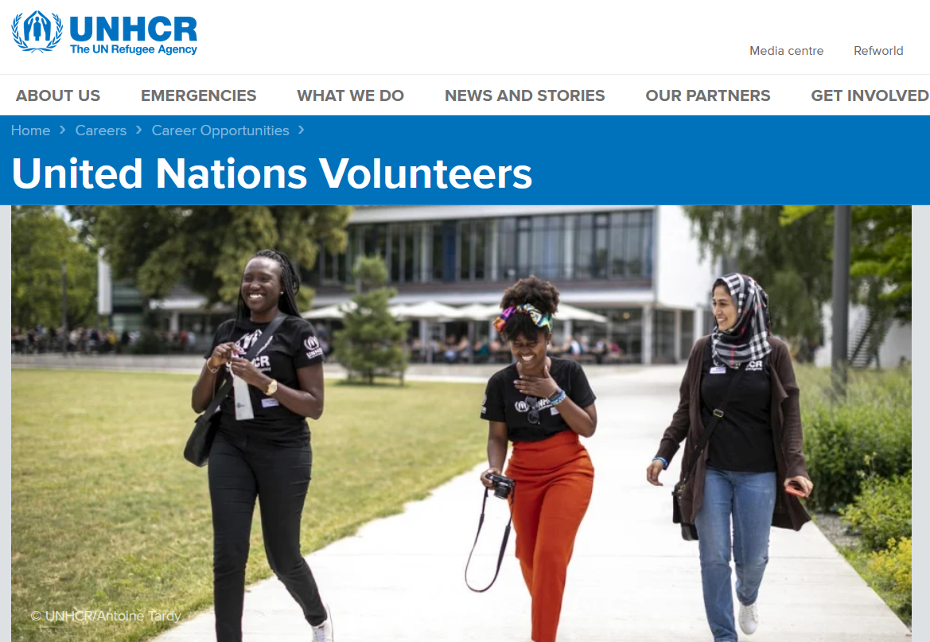
Volunteers provide critical support to help UNHCR. They work in a variety of roles ranging from protection, refugee status determination, programme delivery, communication, information technology to administrative functions and more.
Every year, around 900 UN Volunteers support UNHCR in some 70 countries. Volunteering at UNHCR is a great chance to contribute to your local or host community and to gain work experience in the humanitarian sector. Contracts are usually for 6-12 months, with a maximum period of four years.

A UNHCR volunteer shares her inspirational story:
Alina Kovalenko, National UN Volunteer, Communications and Public Information, Kyiv, Ukraine
Before joining Ukraine’s UNHCR team I spent a year in Indonesia on an exchange program. I found myself in absolutely new environment, faced with numerous challenges. It was there when I understood that I wanted to be the kind of person who supports people new to our culture, help them with their needs. I also felt that I could help displaced people to overcome the sense of fear and uncertainty in a foreign environment by giving them support and empathy. I believe, that peace begins, where stigma ends.
Adapted from: https://www.unhcr.org/united-nations-volunteers.html#

