ΘΕΜΑ 1. ΚΑΤΑΝΟΗΣΗ ΓΡΑΠΤΟΥ ΛΟΓΟΥ
Read the text and decide if each statement (1-10) is True (A) or False (B).
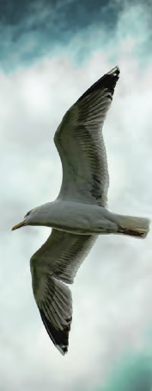
It was morning, and the new sun sparkled gold across the tiny waves of a gentle sea. A fishing boat upset the sea and a thousand of seagulls flew close to the boat to fight for bits of food. It was another busy day beginning. But alone, out by himself and far away from the boat, Jonathan Livingston Seagull was practising. Most seagulls do not bother to learn more than the simplest facts of flying -how to get from shore to food and back again. For most seagulls, it is not flying that is important, but eating. For this seagull, though, it was not eating that was important, but flying. More than anything else, Jonathan Livingston Seagull loved to fly. Other birds didn’t like this kind of thinking. That was why Jonathan Livingston Seagull was alone. Even his parents were disappointed as Jonathan spent his days alone, trying to fly low, just above the sea, stretching his wings in the air.

Statements |  | A | B
 |  | TRUE | FALSE
 | The texts talks about a seagull.
 | The seagulls find their food on the mountains.
 | According to the text, there are many fishing boats in the sea.
 | Jonathan Livingston Seagull is practising how to fly.
 | Jonathan Livingston Seagull likes fishing for food more than anything else.
 | Most seagulls find flying more important than eating.
 | Jonathan Livingston Seagull has many friends.
 | Jonathan Livingston Seagull usually spends his days alone.
 | Jonathan Livingston Seagull’s parents are proud of him.
 | Jonathan Livingston Seagull is practising flying over the hills.

ΘΕΜΑ 2^{α}. ΛΕΞΙΚΟΓΡΑΜΜΑΤΙΚΗ
Fill each gap in sentences 11-20 with the correct word/phrase from the box below (A-J). Use each word only once.
A | fishing boat  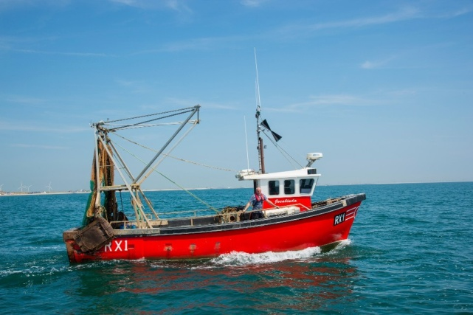 | B | wings  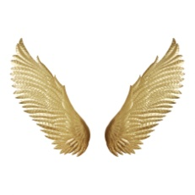 | C | waves  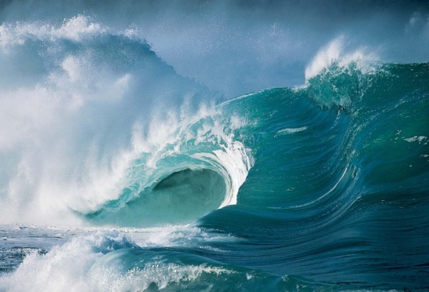 | D | alone   | E  sea | 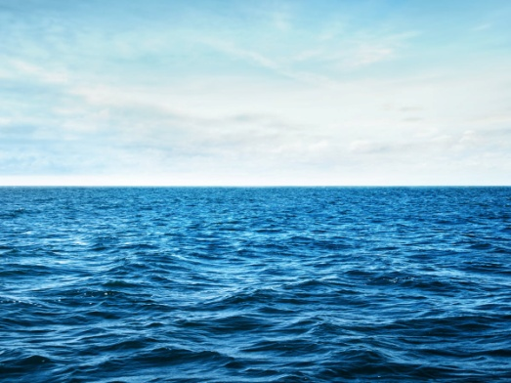
F | morning   | G | 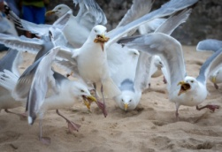  seagulls | H | 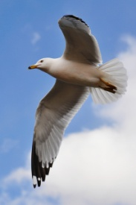  flying | I | 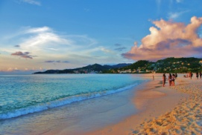  shore | J  disappointed | 

Most _________ love fishing near fishing boats.
I like windsurfing and playing with the ________ in the sea.
Last Saturday, we went swimming in the __________.
My uncle goes fishing on his _________ __________!
When the boat reached the ____________, the fisherman got out of it.
We could see birds____________ in the sky.
When I am sad, I want to be ____________.
He couldn’t find a job and he felt really __________.
Can we meet first thing tomorrow _____________?
Birds can fly because they have got ____________.

