ΘΕΜΑ 1. ΚΑΤΑΝΟΗΣΗ ΓΡΑΠΤΟΥ ΛΟΓΟΥ
Read the text and decide if each statement (1-10) is True (A) or False (B).
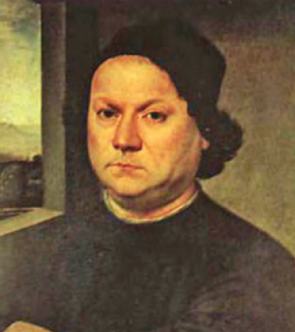
Andrea del Verrocchio (c. 1435-1488) was born in Florence in or about 1435. He was an Italian sculptor, goldsmith and painter who worked for Lorenzo de Medici in Florence in the early Renaissance. His painting “Tobias and the angel’’ is now in London at the National Gallery. “The Baptism of Christ”, now in the Uffizi Gallery in Florence, was painted in 1474-1475. In this work, Verrocchio was helped by Leonardo da Vinci, one of his students. Da Vinci painted the angel on the left. Then, Verrocchio stopped painting because he thought that Da Vinci, his student, was better than the teacher (himself). His last work is the magnificent statue of Bartolomeo Colleoni in Venice. “The Madonna enthroned with John the Baptist and St Donato” is in the Cathedral at Pistoia. Lorenzo di Credi completed it. Verrocchio died in Venice in 1488. He is one of the most important Italian sculptors of the Renaissance.

Statements |  | A | B
 |  | TRUE | FALSE
 | Andrea del Verrocchio was born in Florence.
 | Verrocchio was a painter, sculptor and goldsmith.
 | Verrocchio worked for Lorenzo de Medici.
 | ‘’Tobias and the Angel’’ is found in a gallery.
 | Verrocchio painted “The Baptism of Christ” alone.
 | “The Baptism of Christ” is now in the Vatican City in Rome.
 | “The Baptism of Christ” was painted in 1435.
 | The Baptism of Christ” was Verrocchio’s last work.
 | Verrocchio himself completed “The Madonna enthroned with John the Baptist and St Donato”.
 | Verrochio died in Florence.

ΘΕΜΑ 2^{α}. ΛΕΞΙΚΟΓΡΑΜΜΑΤΙΚΗ
Match each picture below (11-20) with a word from the box (A-J). Use each word only once.
A. | to paint | B. | a statue | C. | a painting | D. | a sculptor | E. | a painter
F. | an angel | G. | Christ | H. | a teacher | I. | a gallery | J. | a student

 | 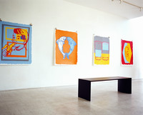
 | 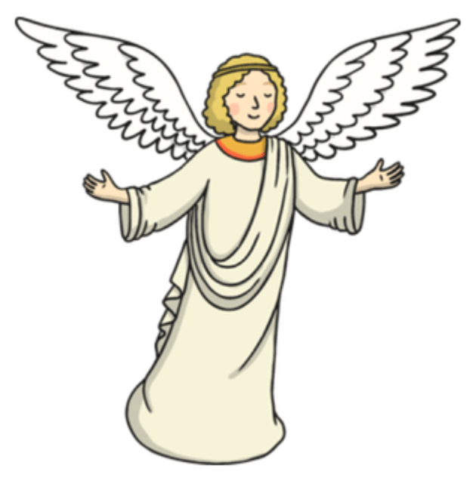
 | 
 | 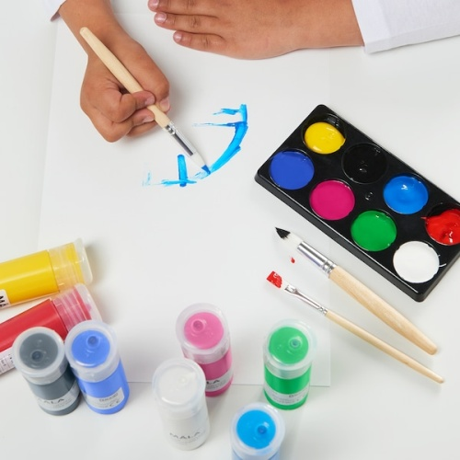
 | 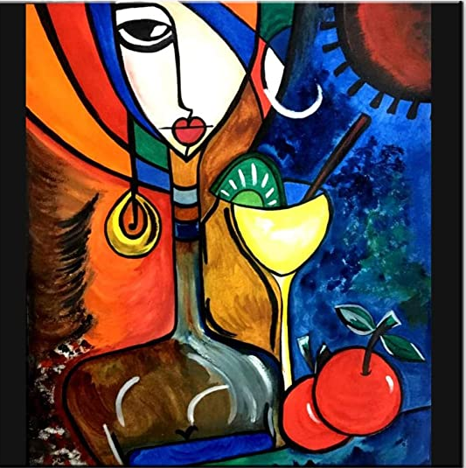
 | 
 | 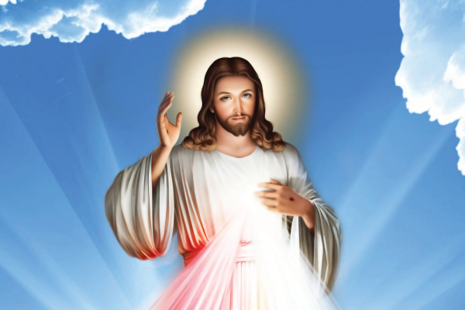
 | 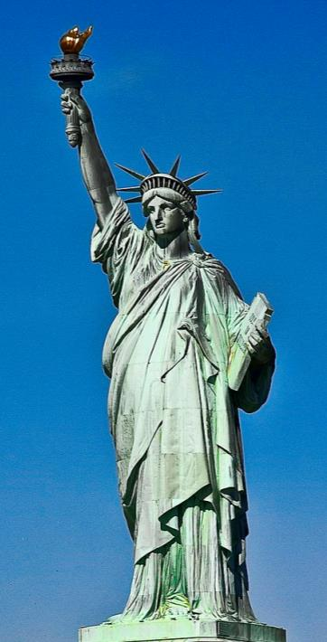
19. | 
20. | 

