ΘΕΜΑ 1. ΚΑΤΑΝΟΗΣΗ ΓΡΑΠΤΟΥ ΛΟΓΟΥ
Read the text and decide if each statement (1-10) is True (A) or False (B).
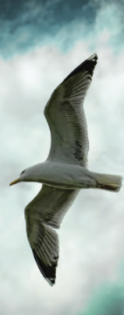
It was morning, and the new sun sparkled gold across the tiny waves of a gentle sea. A fishing boat upset the sea and a thousand of seagulls flew close to the boat to fight for bits of food. Another busy day was beginning. But alone, out by himself and far away from the boat, Jonathan Livingston Seagull was practising. In the sky he lowered his feet, lifted his beak, and tried hard to hold himself in the air with his wings. He slowed until the ocean was beneath him. He held his breath, then his feathers trembled, he stopped and fell. Seagulls, as you know, never stop. To stop in the air is for them dishonour. But Jonathan Livingston Seagull, brave, stretching his wings again - slowing, slowing, and stopping once more - was no ordinary bird.

Statements |  | A | B
 |  | TRUE | FALSE
 | The texts describes a rainy day.
 | In the text, the seagulls are searching for food in the sea.
 | The seagulls are following a fishing boat.
 | Jonathan Livingston Seagull is fishing together with the other seagulls.
 | Jonathan Livingston Seagull is close to the fishing boat.
 | Jonathan Livingston Seagull’s practice is an easy thing to do.
 | Jonathan Livingston Seagull is under the water when he is practising.
 | Jonathan Livingston Seagull stopped and fell while practising.
 | Seagulls like stopping in the air.
 | Jonathan Livingston Seagull is a seagull like all the other seagulls.

ΘΕΜΑ 2^{α}. ΛΕΞΙΚΟΓΡΑΜΜΑΤΙΚΗ
Match each picture below (11-20) with a word/phrase from the box (A-J). Use each word only once.
A. | seagull | B. | beak | C. | sea | D. | feathers | E. | sun
F. | fishing boat | G. | feet | H. | wings | I. | waves | J. | sky

 | 
 | 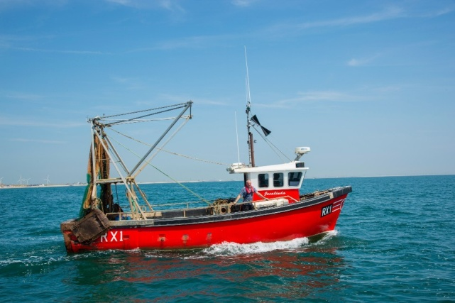
 | 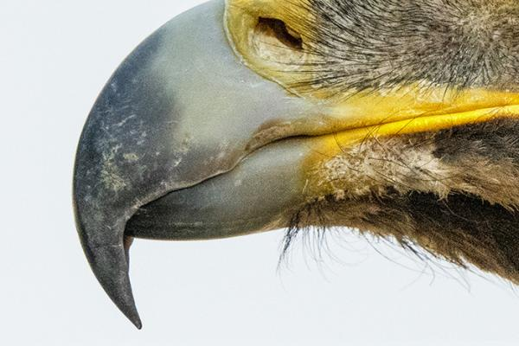
 | 
 | 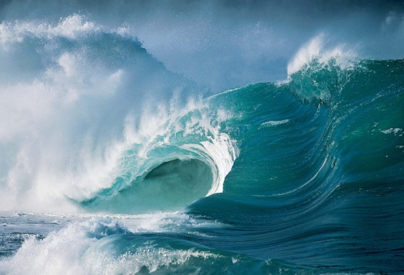
 | 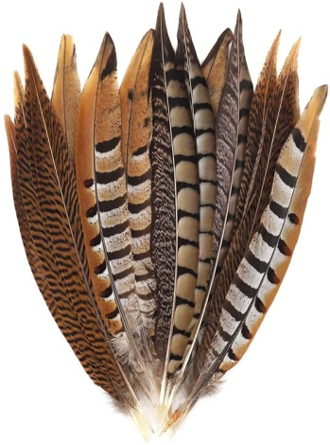
 | 
 | 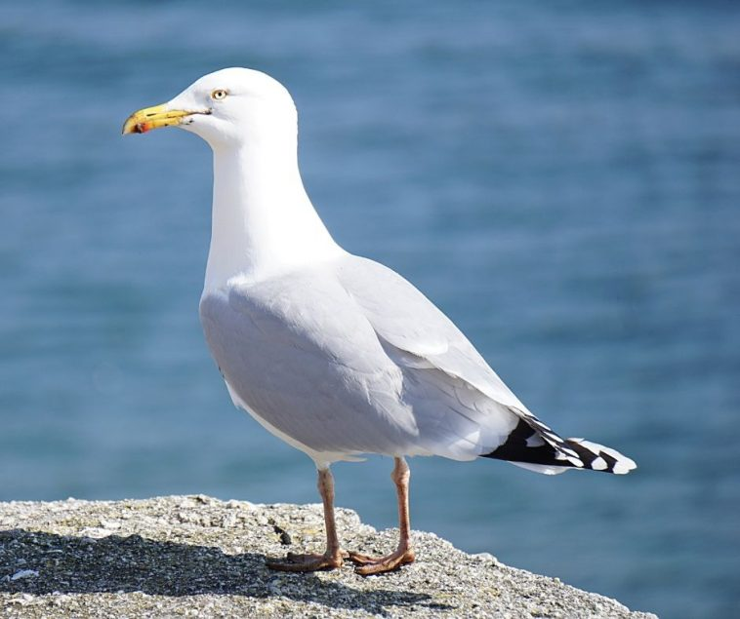
19. | 
20. | 

