ΘΕΜΑ 1. ΚΑΤΑΝΟΗΣΗ ΓΡΑΠΤΟΥ ΛΟΓΟΥ
Read the text and decide if each statement (1-10) is True (A) or False (B).

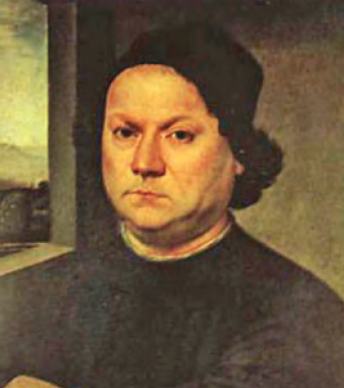
Andrea del Verrocchio (c. 1435-1488) was born in Florence in or about 1435. His father was a tile and brick maker and, later, a tax collector. Verrocchio never married because he had to support his family. He was an Italian sculptor, goldsmith and painter who worked for Lorenzo de Medici in Florence in the early Renaissance. He trained many important painters at his workshop. His pupils included Leonardo da Vinci, Pietro Perugino and Lorenzo di Credi. When one of his students, Leonardo Da Vinci, became better than him, Verrocchio stopped painting. His last work is the magnificent statue of Bartolomeo Colleoni in Venice. He died in Venice in 1488. He is one of the most important Italian sculptors of the Renaissance.

Statements |  | A | B
 |  | TRUE | FALSE
 | Andrea del Verrocchio was born in Rome.
 | Verrocchio’s father was a teacher.
 | Verrocchio got married and had two children.
 | Verrocchio worked as a tax collector.
 | Verrocchio only painted in his life.
 | Lorenzo di Credi was one of Verrocchio’s students.
 | Leonardo da Vinci was better at painting than Verrocchio.
 | Verrocchio’s last work is a famous painting.
 | The statue of Bartolomeo Colleoni is found in Venice.
 | Verrochio was a very important Spanish sculptor.

ΘΕΜΑ 2^{α}. ΛΕΞΙΚΟΓΡΑΜΜΑΤΙΚΗ
Match each underlined word/phrase in the sentences below (11-20) with a picture from the box (A-J). Use each picture only once.
A | 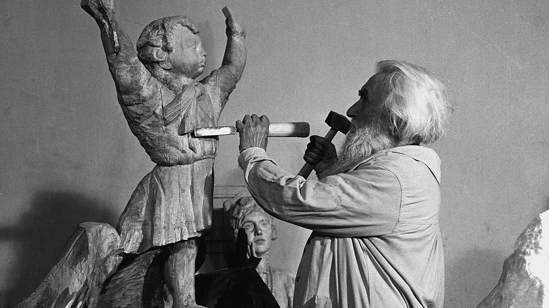 | B |  | C | 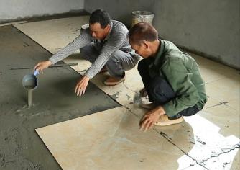 | D |  | E | 
F | 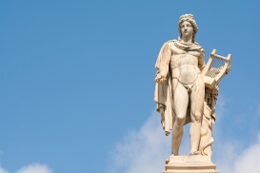 | G |  | H | 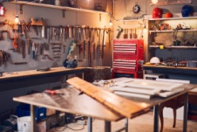 | I |  | J | 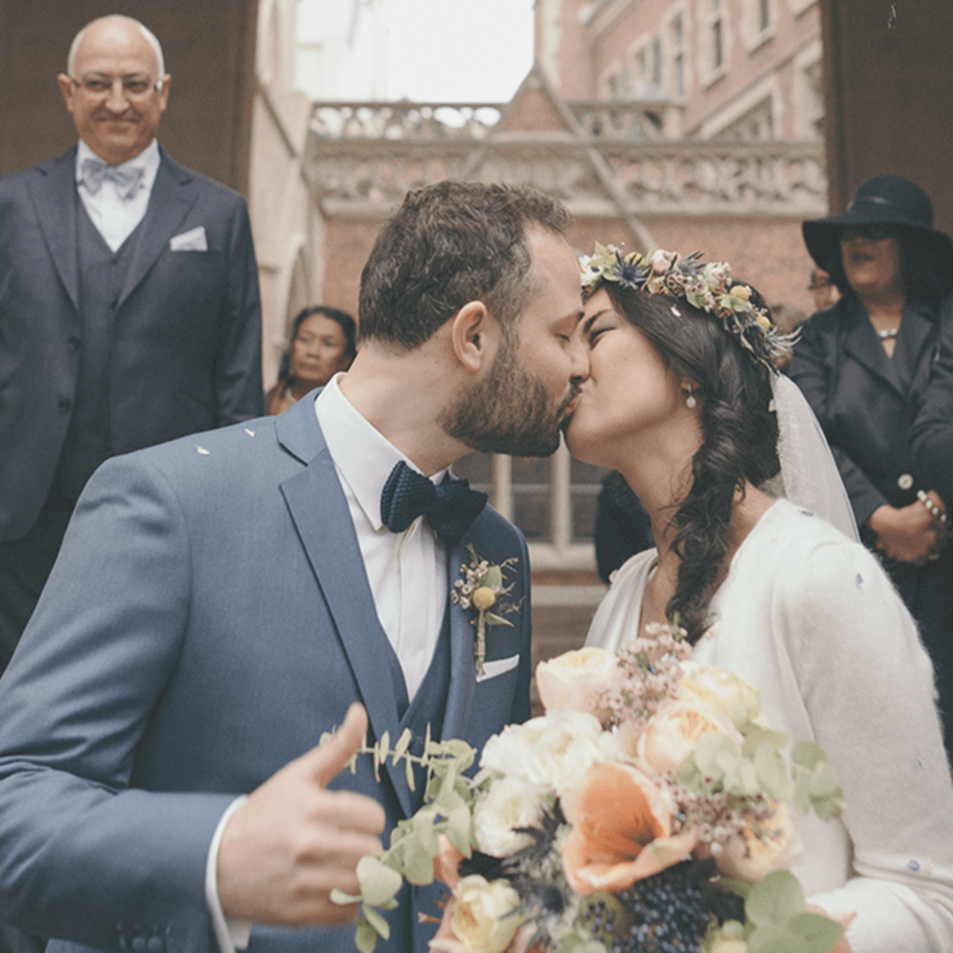

James and Martha got married last summer.
A brick broke the window in our kitchen.
A sculptor makes beautiful statues.
My sister, Lisa, is a university student.
Artists spend a lot of hours in their workshop.
They are a happy family.
In our tour in Athens we admired the statue of Apollo.
Bob Ross was a famous painter.
We had to put new tiles in our bathroom.
She decided to paint her room by herself.

