ΘΕΜΑ 1. ΚΑΤΑΝΟΗΣΗ ΓΡΑΠΤΟΥ ΛΟΓΟΥ
Read the text and decide if each statement (1-10) is True (A) or False (B).
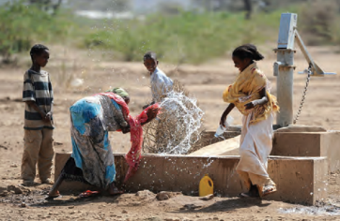
Kakuma is found in Kenya, very close to Ethiopia, Uganda and the Sudan. The refugee camp is in a dry and sunny place. The sun is so hot there! At the end of the refugee camp, there is a lonely plastic hut. Mesfin lives alone in the hut. He lives by himself in this land. The hut is not a house. It just protects Mesfin from the sun. He says "It is my house". When Mesfin feels stressed, lonely and hungry, he usually walks in the forest. Moreover, when he does not have firewood, he walks for about twenty kilometres to bring some wood. The wood is necessary for Mesfin to cook his food. He cannot buy charcoal because he does not have money and he cannot collect charcoal because Turkana people will not let him. So, finding firewood in the forest is the only way for Mesfin to live.

Statements |  | A | B
 |  | TRUE | FALSE
 | Kakuma is a place in Uganda.
 | There is a refugee camp in Kakuma.
 | It is hot in Kakuma.
 | It is rainy in Kakuma.
 | Mesfin’s hut is made of plastic.
 | There are a lot of huts around Mesfin’s hut.
 | Mesfin needs wood to cook his food.
 | Masfin has to cook his own food.
 | Mesfin cannot buy charcoal from the Turkana people.
 | Turkana people help Mesfin to find charcoal.

ΘΕΜΑ 2^{α}. ΛΕΞΙΚΟΓΡΑΜΜΑΤΙΚΗ
Match each picture below (11-20) with a word from the box (A-J). Use each word only once.
A. | forest | B. | money | C. | charcoal | D. | hungry | E. | stressed
F. | firewood | G. | hut | H. | walk | I. | cook | J. | lonely

 | 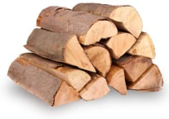
 | 
 | 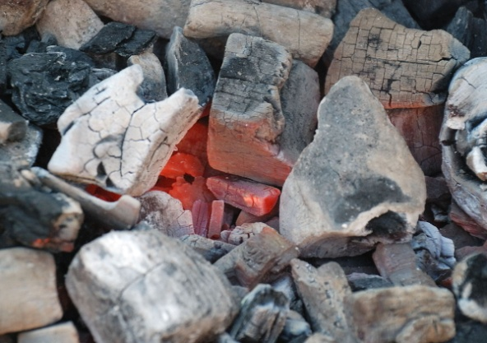
 | 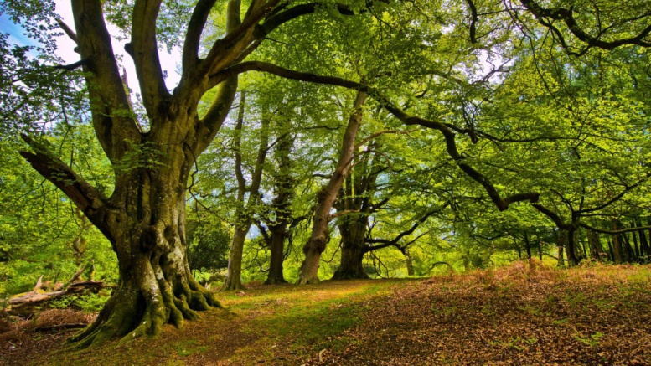
 | 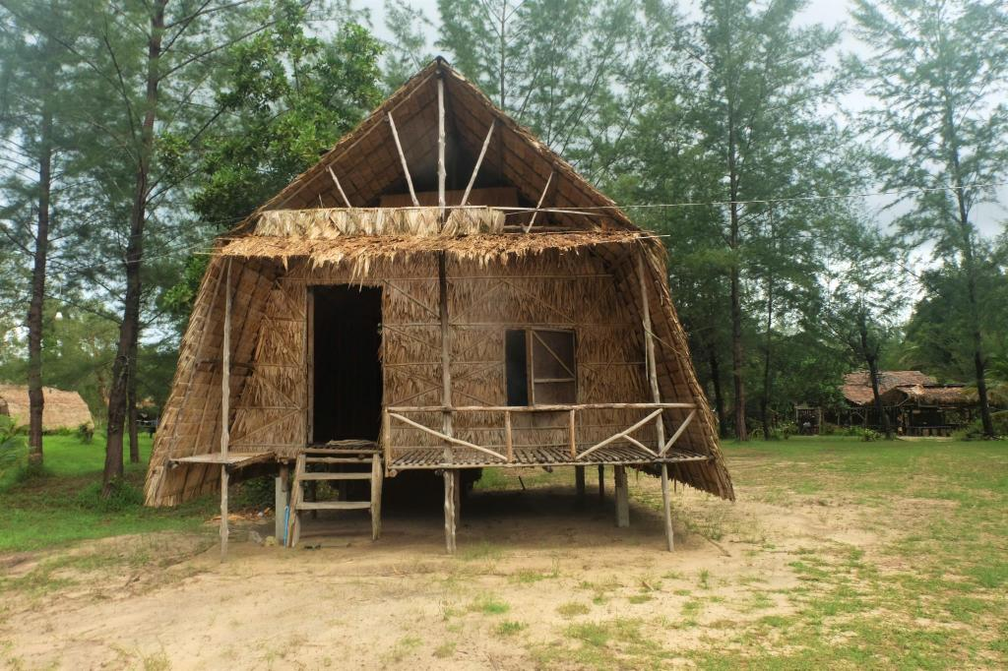
 | 
 | 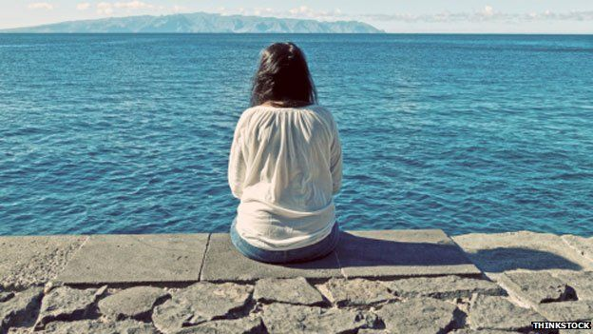
 | 
19. | 
20. | 

