ΘΕΜΑ 1. ΚΑΤΑΝΟΗΣΗ ΓΡΑΠΤΟΥ ΛΟΓΟΥ
Read the text and decide if each statement (1-10) is True (A) or False (B).
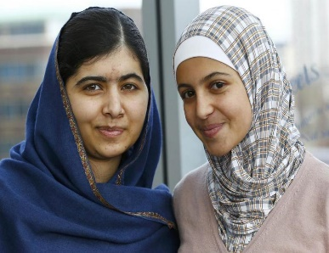
Leaving the war in Syria, Muzon and her family stayed in a refugee camp in Jordan. As Muzon continued going to school in the camp, she saw that many of her fellow pupils stopped school, often girls. She heard about one girl who had left school and was trying to sell her schoolbooks. Muzon found her and made her change her mind. Her friendship with Malala, a Pakistan girl who fights for women’s right to education as well, made Muzon stronger to fight for girls and young women’s right to education. She thinks that people should understand the importance of education in life. “Being a refugee doesn’t have to destroy your life. Many successful people face difficulties in their lifetime.”

Statements |  | A | B
 |  | TRUE | FALSE
 | This text is about the war in Syria.
 | Muzon comes from Syria.
 | Muzon is a refugee.
 | Muzon cannot go to school in the refugee camp.
 | All girls in the refugee camp go to school.
 | Muzon helped a girl to go back to school.
 | Malala and Muzon are friends.
 | Malala helped Muzon find a job.
 | Muzon believes that education is important.
 | Muzon thinks that successful people do not face any difficulties in life.

ΘΕΜΑ 2^{α}. ΛΕΞΙΚΟΓΡΑΜΜΑΤΙΚΗ
Fill each gap in sentences 11-20 with the correct word/phrase from the box below (A-J). Use each word/phrase only once.
A | stronger   | B | refugees  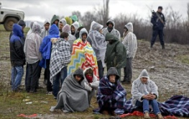 | C | girl   | D | fight   | E  schoolbooks | 
F | war  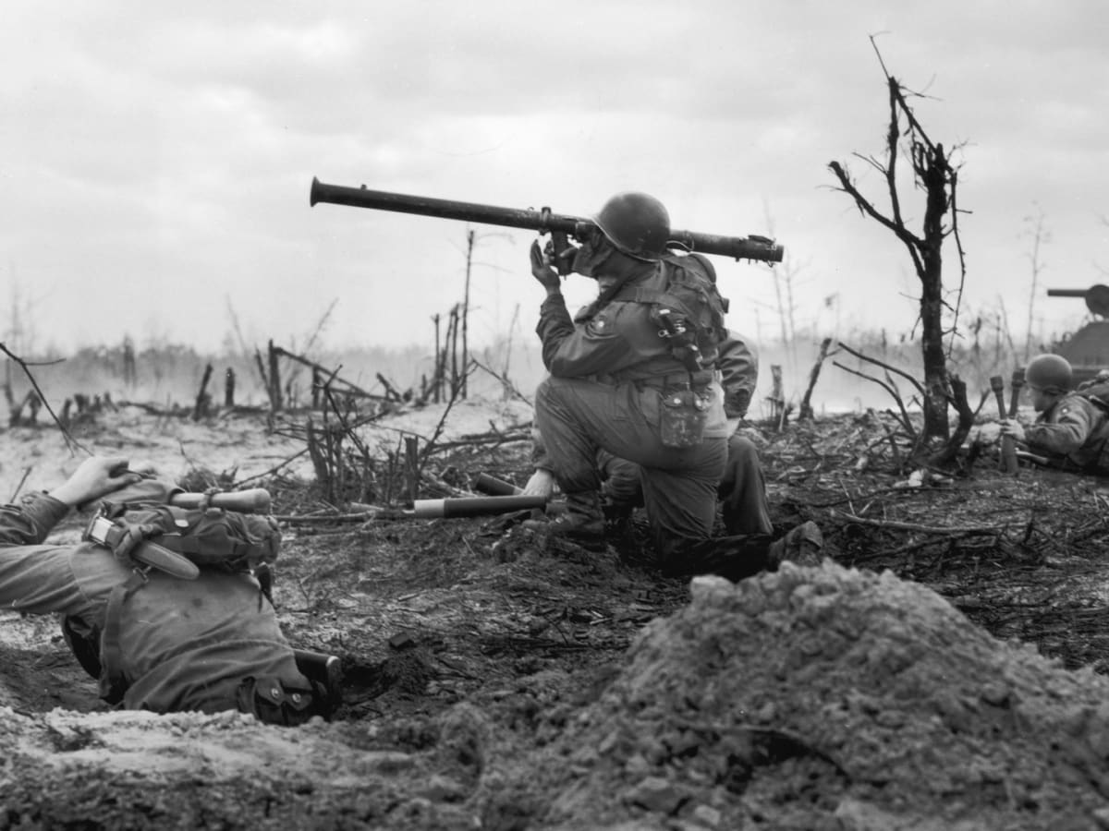 | G |   pupils | H |   sell | I |   friends | J |   school

Look at this beautiful _________! She is my sister.
Students finish ________ at 14:00.
Every evening I get ready for school and I put my __________ in my schoolbag.
I have a lot of fun with my __________!
She is exercising to become ____________.
We should help ____________ to find a safe place to stay.
____________ learn a lot of interesting things at school.
If this country goes to __________, many people will die.
I want to _____________ my old car and buy a new one.
The two men had a terrible ____________ and then stopped talking to each other.

