ΘΕΜΑ 1. ΚΑΤΑΝΟΗΣΗ ΓΡΑΠΤΟΥ ΛΟΓΟΥ
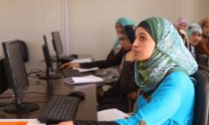
Read the text and decide if each statement (1-10) is True (A) or False (B).
Muzon, a refugee from Syria, is a strong fighter for the education of girls and young women in Jordan’s refugee camps. Muzon’s family escaped the war in Syria in early 2013. Back then, smart 14-year-old Muzon was ready to take her school exams. So, her family briefly thought of leaving her behind, but, in the end, her father decided the risks were too great. So, Muzon and her family travelled to Jordan. Now at the age of 17, Muzon continues school in Jordan. Moreover, she supports education for Syrian refugees, especially young women and girls. Muzon has, also, become a friend to Malala, a Pakistan girl who fights for women’s right to education as well. “Malala taught me that no matter what difficulties I have in life, I can be a winner”, Muzon said. Before the war began, Muzon had a normal life with her family and friends in Syria. But when the war began, they had to run away from Syria to Jordan and stay at Za’atari refugee camp.

Statements |  | A | B
 |  | TRUE | FALSE
 | Muzon now lives in a refugee camp.
 | Muzon supports women’s right to education.
 | Muzon left Syria because it was too hot to live in.
 | When in Syria, Muzon was getting ready for her school exams.
 | Muzon left her country when she was 14 years old.
 | Muzon left her country alone.
 | Muzon’s family left Syria and went to Iraq.
 | Malala and Muzon are friends.
 | Malala is from Pakistan.
 | Back in Syria, Muzon had a normal life.

ΘΕΜΑ 2^{α}. ΛΕΞΙΚΟΓΡΑΜΜΑΤΙΚΗ
Match each picture below (11-20) with a word/phrase from the box (A-J). Use each word/phrase only once.
A. | fight | B. | war | C. | school | D. | friends | E. | travel
F. | exams | G. | boat | H. | family | I. | refugee camp | J. | student

 | 
 | 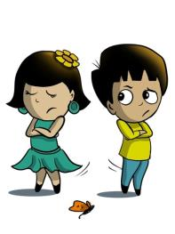
 | 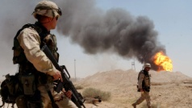
 | 
 | 
 | 
 | 
 | 
19. | 
20. | 