ΘΕΜΑ 1. ΚΑΤΑΝΟΗΣΗ ΓΡΑΠΤΟΥ ΛΟΓΟΥ
Read the text and decide if each statement (1-10) is True (A) or False (B).
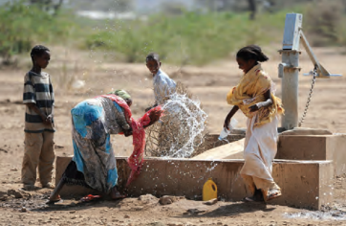
Kakuma is found in Kenya, very close to Ethiopia, Uganda and the Sudan. The refugee camp is in a dry and sunny place. The sun is so hot there! At the end of the refugee camp, there is a lonely plastic hut. Mesfin, one of the refugees, lives alone in the hut. He lives by himself in this land. The hut is not a house. It just protects Mesfin from the sun. He says "It is my house". When Mesfin feels stressed, lonely and hungry, he usually walks in the forest. Moreover, when he does not have firewood, he walks for about twenty kilometres to bring some wood. The wood is necessary for Mesfin to cook his food. Having a piece of wood is the difference between eating and going to bed without food. So, to cook and eat a good meal, he has to get up very early and go to find firewood.

Statements |  | A | B
 |  | TRUE | FALSE
 | The text talks about a refugee in Kenya.
 | Kenya is close to Uganda.
 | Kenya is far away from the Sudan.
 | Kakuma is a cold place.
 | Mesfin is a refugee.
 | Mesfin lives with his family in the refugee camp.
 | Mesfin has a lot of friends.
 | Firewood is necessary for Mesfin to cook his food.
 | It is easy for Mesfin to find firewood.
 | There is a chef who cooks for all refugees in the camp.

ΘΕΜΑ 2^{α}. ΛΕΞΙΚΟΓΡΑΜΜΑΤΙΚΗ
Match each underlined word/phrase in the sentences below (11-20) with a picture from the box (A-J). Use each picture only once.
A | 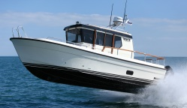 | B | 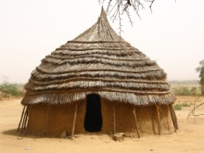 | C | 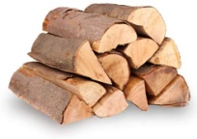 | D | 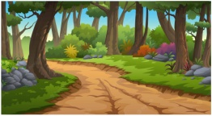 | E | 
F |  | G | 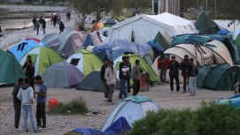 | H |  | I | 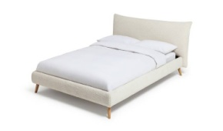 | J | 

If you like cooking, you can become a chef.
There was a hut in the middle of the jungle.
There was a large bed In her room.
Many refugees from Syria live in this refugee camp.
We need some firewood for the fireplace.
In summer you should protect yourself from the hot sun
Eating well is important for children.
Walking in a forest is so relaxing!
My house is close to my school.
Do you like travelling by boat?

