ΘΕΜΑ 1. ΚΑΤΑΝΟΗΣΗ ΓΡΑΠΤΟΥ ΛΟΓΟΥ
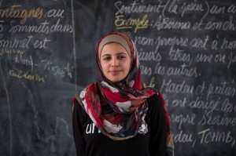
Read the text and decide if each statement (1-10) is True (A) or False (B).
After they had escaped the war in Syria, Muzon and her family stayed in a refugee camp in Jordan. The change was difficult. Back home, Muzon had her own room but now the whole family had to share a single tent where they slept, cooked and washed. Fortunately, Muzon could go to school in the camp. She took summer classes to understand the new school system in Jordan and then she had exams. As she continued school, she saw that many of her fellow pupils stopped classes, often girls around her own age. She heard about one girl that had stopped school and was trying to sell her schoolbooks. Muzon found her and made her change her mind. A fighter for girls’ education was born. “After that, I began speaking for education to my friends, their parents, neighbours or even just girls I met in the street,” she says.

Statements |  | A | B
 |  | TRUE | FALSE
 | The text talks about a refugee girl.
 | Muzon lives in a refugee camp in Jordan.
 | Muzon is from Syria.
 | It is easy for Muzon’s family to live in a camp.
 | In Syria, Muzon shared her bedroom with her family.
 | In Jordan, Muzon’s family lives in a tent.
 | In Jordan, Muzon does not go to school.
 | In the refugee camp, some pupils stop school.
 | Muzon helped one girl to start school again.
 | Muzon fights for girls’ education.

ΘΕΜΑ 2^{α}. ΛΕΞΙΚΟΓΡΑΜΜΑΤΙΚΗ
Match each underlined word in the sentences below (11-20) with a picture from the box (A-J). Use each picture only once.
A | 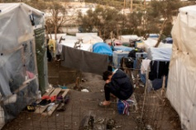 | B |  | C |  | D |  | E | 
F | 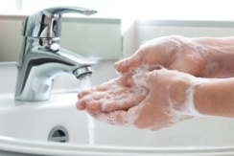 | G |  | H | 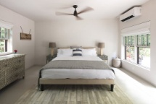 | I |  | J | 

Always wash your hands before eating!
Life is difficult in a refugee camp.
Exams are stressful for students.
Pupils have to be quiet in the classroom.
My grandparents live with us. We are a big family!
My room is large and tidy.
You have to sleep well every night.
My school is close to a park.
In summer we go swimming every day.
She loves cooking and she wants to become a chef.

