ΘΕΜΑ 1. ΚΑΤΑΝΟΗΣΗ ΓΡΑΠΤΟΥ ΛΟΓΟΥ
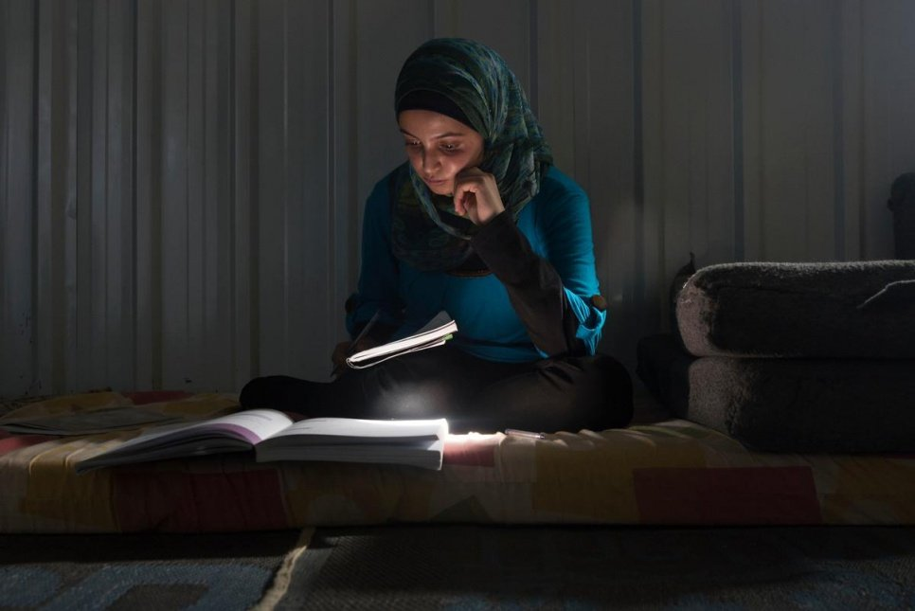
Read the text and decide if each statement (1-10) is True (A) or False (B).
Muzon is a strong supporter of girls and young women’s right to education in Jordan’s refugee’s camps. She reminds us of Malala’s fight in Pakistan. Muzon’s family escaped the war in Syria in 2013. At first her parents thought of leaving her behind. Muzon, 14 years old, was a very good student. She had been studying hard all year for her end-of-school exams. Her aunt told the family to let her stay and continue her education. However, her father decided that the risks were too great. So the girl left the country with her family to Jordan’s Azraq refugee camp. Education has always been important in Muzon’s life. Both of her parents were teachers in Syria and her aunt and uncle were head teachers at local schools. “Our house was built by an engineer. When I was sick I went to a doctor. Education is everything in life.” Muzon said.

Statements |  | A | B
 |  | TRUE | FALSE
 | Muzon is a teacher.
 | Muzon lives in a refugee camp in Syria.
 | Malala is from Pakistan.
 | Muzon stayed with her aunt in Syria to finish school.
 | Muzon left her country when she was four years old.
 | Muzon’s family went to Jordan after leaving their country.
 | Nowadays, Muzon is staying at an expensive hotel.
 | Muzon’s parents were engineers in Syria.
 | Muzon believes that education is not at all important.
 | An engineer helped Muzon’s family to build their house in Syria.

ΘΕΜΑ 2^{α}. ΛΕΞΙΚΟΓΡΑΜΜΑΤΙΚΗ
Match each underlined word in the sentences below (11-20) with a picture from the box (A-J). Use each picture only once.
A | 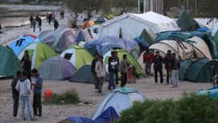 | B |  | C |  | D |  | E | 
F |  | G |  | H |  | I | 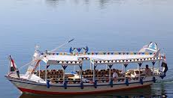 | J | 

She is studying to become an engineer.
In a war, many people are killed.
Taking exams is stressful for students.
In Greece many refugees live in camps.
My grandparents live with us. We are a big family!
At school students learn a lot of interesting things.
I love my Maths teacher because she is very patient.
My school is close to my house.
My house is near a park.
Many people enjoy travelling by boat.

