ΘΕΜΑ 1. ΚΑΤΑΝΟΗΣΗ ΓΡΑΠΤΟΥ ΛΟΓΟΥ
Read the text and choose the correct option (True or False) for items 1-10.
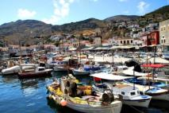
Teacher: Harry, why is Hydra quiet?
Harry: Because there isn’t much traffic there, and there aren’t any factories.
Teacher: You could be right. Gina?
Gina: There can’t be much traffic. Hydra is very small.
George: I’m not sure, but Hydra has no other town or village, only the main port. The island is dry and all rocks.
Teacher: You almost got the answer. There aren’t any cars on the island. You can find only mules and donkeys. You can use your feet, of course, if you like!
Nick: I don’t like walking up difficult roads.
Teacher: What about its history? Does anybody know about Hydra’s history?
Class……
Teacher: Come on say something.
Elena: All I know is that Hydra was important in the Greek War in 1821.
Teacher: Bravo Elena! Well, you can find some information on Hydra’s history in our school library.

STATEMENTS | TRUE | FALSE
- Hydra is a quiet island.
- There are no factories on Hydra.
- Hydra is full of trees.
- You can drive your car on the island of Hydra.
- Nick loves walking up difficult roads.
- You cannot see any donkeys on Hydra.
- Hydra is a very big island.
- Hydra was important in the Greek War in 1821.
- Students can find information on Hydra’s history by surfing the net.
- The conversation takes place in a classroom.

ΘΕΜΑ 2^{α}. ΛΕΞΙΚΟΓΡΑΜΜΑΤΙΚΗ
Match each of the sentences below (11-20) with the correct word from the box below (A-J). Use each word only once.
A | port   | B | donkey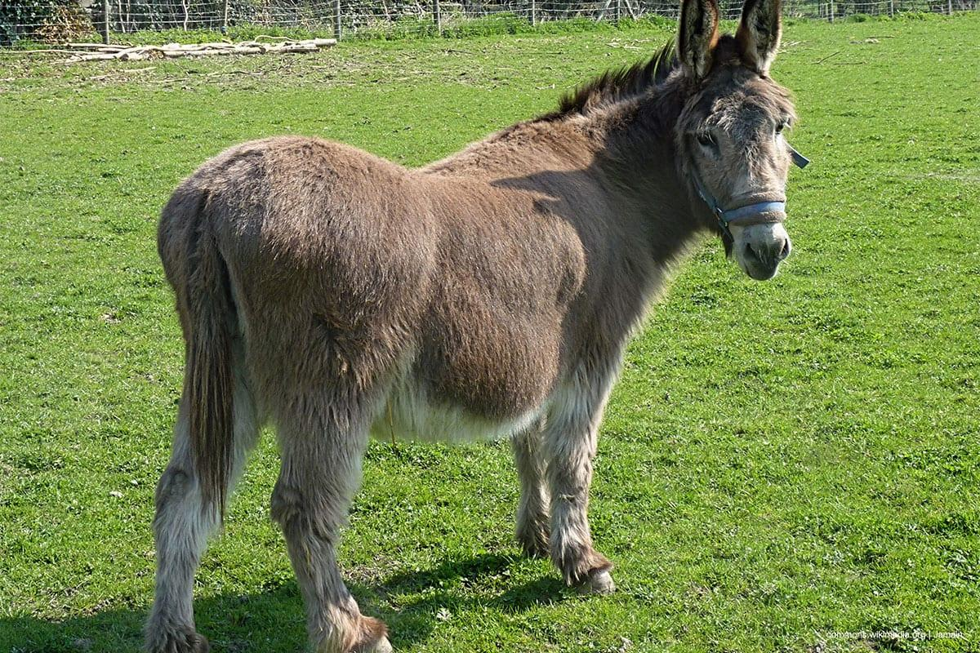  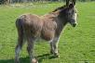 | C | island   | D | feet  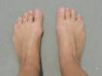 | E |   road
F |   classroom | G |   library | H | 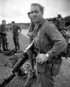  war | I | 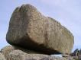  rock | J |   factory

A place where large amounts of goods are made using machines.
A place where you can read or borrow books.
A room in a school where students learn new things.
A hard piece of earth.
The part of our body at the bottom of our legs.
An animal like a small horse with long ears.
A piece of land with water around it.
A place for ships.
People drive on it when traveling by car.
A serious fight between two or more countries.

