ΘΕΜΑ 1. ΚΑΤΑΝΟΗΣΗ ΓΡΑΠΤΟΥ ΛΟΓΟΥ
Read the text and choose the correct option (True or False) for items 1-10.
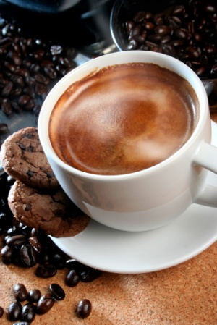
Tony, Harry, Elena, Gina, George, Nick and their teacher, Miss Anna Stratou, are at a cafeteria in a nearby town during a school trip. They are all busy reading the menu.
Miss Anna: Are you ready? Let’s call the waitress. Waitress!
Waitress: Yes, Miss? Have you chosen?
Miss Anna: Almost. One fruit cocktail for me, an ice-cream for George…
George: I’d prefer the ice-cream with the cherry on top in the blue-pink bowl you serve it in.
Waitress: Anything else?
Miss Anna: Elena, Tony, Gina, Nick, Harry, what will you have?
Elena: I’ll have a salad and a sandwich.
Tony: I’ll have a coke.
Gina: Me too.
Nick: I’ll have a nice piece of fruitcake and an ice-cream like George’s.
Harry: I’d like a milk shake.
Waitress: OK. Anything else?
Miss Anna: No, thank you. Er, wait, please, there’s another boy coming on his bicycle. Hey, Bill, shall we order something for you? ... What? ... OK. A fresh orange juice for the boy, please.

Statements |  | A | B
 |  | TRUE | FALSE
 | The students are at a cafeteria.
 | Miss Anna Stratou is a waitress.
 | Miss Anna Stratou orders a fruit cocktail.
 | George wants a coke.
 | Elena wants only a salad.
 | Nick wants a piece of fruitcake and an ice-cream.
 | Harry wants a milkshake.
 | Gina doesn't want a coke.
 | Bill is riding his bike.
 | Bill doesn't want to order anything.

ΘΕΜΑ 2^{α}. ΛΕΞΙΚΟΓΡΑΜΜΑΤΙΚΗ
Match each one of the sentences 11-20 with the correct word/phrase from the box below (A-J). Use each word/phase only once.
A | town  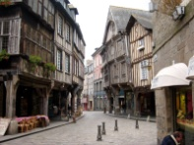 | B | ice-cream  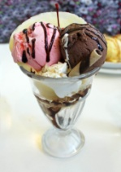 | C | read   | D | menu  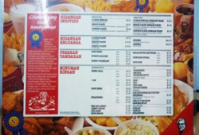 | E  waitress | 
F | 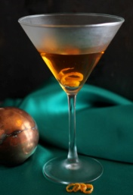  coctail | G | 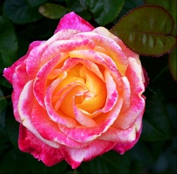  pretty | H | 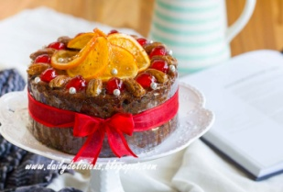  fruitcake | I | 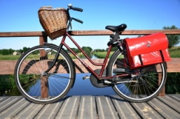  bicycle | J  order | 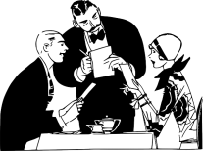

To ask for food in a cafeteria/restaurant.
A woman who serves people in a cafeteria/restaurant.
A cake made with different kinds of fruit.
A place smaller than a city.
A drink made by mixing two or more drinks together.
A list of the food that you can eat in a restaurant.
To look at words and understand what they mean.
An object that is nice to look at.
A soft, sweet frozen food made with milk and cream.
You sit on it and you move by turning the two pedals. It has two wheels, too.

