ΘΕΜΑ 1. ΚΑΤΑΝΟΗΣΗ ΓΡΑΠΤΟΥ ΛΟΓΟΥ
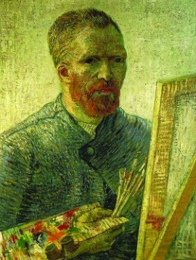
Read the text and decide if each statement (1-10) is True (A) or False (B).
After Van Gogh’s death, many artists liked his work and tried to paint like him. Vincent’s brother’s wife collected Vincent’s paintings and letters after his death. This is how Van Gogh became famous. In ten years Van Gogh painted around 900 paintings. Now many of his paintings are very expensive. Van Gogh's painting “Irises” was sold for a record $53.9 million in New York. His “Portrait of Doctor Gachet” was sold for $82.5 million. Vincent van Gogh wrote a lot of letters to his friends and family. We can still see more than 800 of these letters. Other people sent to him 80 letters as well. Van Gogh said that writing is just like painting.

Statements |  | A | B
 |  | TRUE | FALSE
 | Van Gogh became very famous while he was still alive.
 | Van Gogh’s brother’s wife collected Van Gogh’s paintings and letters.
 | Van Gogh painted his paintings in 20 years.
 | Van Gogh painted around 800 paintings during his lifetime.
 | To buy one of Van Gogh’s paintings, you must pay a lot of money.
 | His ‘’Portrait of Doctor Gachet’’ is more expensive than ‘’Irises’’.
 | ‘’Irises’’ was sold in New York.
 | Van Gogh wrote many letters.
 | Van Gogh wrote letters only to his friends.
 | Today we have only 80 of the letters written by Van Gogh.

ΘΕΜΑ 2^{α}. ΛΕΞΙΚΟΓΡΑΜΜΑΤΙΚΗ
Fill each gap in sentences 11-20 with the correct word/phrase from the box below (A-J). Use each word/phrase only once.
A | New York   | B | doctor   | C | irises   | D | friends   | E | artist  
F |   paint | G |   writing | H |   family | I |   paintings | J  letters | 

I live with my _________in a nice house.
An ________ gets paid every time s/he sells one of his/her paintings.
______________ is a very big city with very tall buildings in the United States.
You can buy different ____________ from an art gallery.
My daughter likes ____________ in her diary every night.
She wanted to ___________ her bedroom by herself.
The postman brought some ____________ today.
A __________ works in a hospital.
My grandma has beautiful _____________ in her garden.
I like going out with my ____________ from school; we have a great time together!

