ΘΕΜΑ 1. ΚΑΤΑΝΟΗΣΗ ΓΡΑΠΤΟΥ ΛΟΓΟΥ
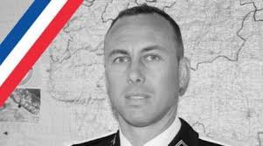
Read the text and decide if each statement (1-10) is True (A) or False (B).
Christian Guibbert, a former police officer, was shopping in a supermarket when he heard shots. It all happened near a quiet town of 5,000 people in France. At about 11:00 last Friday morning, a man of 25 walked into the supermarket shouting “Allahu Akbar”. Around 50 people were inside the building. The criminal killed one supermarket worker and one customer. The criminal, called Radouane Lakdim, was born in Morocco and lived in Carcassonne. He had spent some time in prison for small crimes in 2015. The supermarket attack lasted just over three hours. Lakdim was holding many people inside the supermarket. A French police officer called Arnaud Beltrame offered to take the people’s place. Lakdim shot the officer and Beltrame died from his injuries a day later at hospital. The police officer was a real hero!

Statements |  | A | B
 |  | TRUE | FALSE
 | Christian Guibbert was a police officer in the past.
 | The town near the supermarket has 5,000 people.
 | The supermarket attack happened in Germany.
 | The criminal went into the supermarket on a Saturday morning.
 | The criminal was born in Morocco.
 | The criminal lived in Morocco.
 | The criminal killed two supermarket workers.
 | Arnaud Beltrame was a French police officer.
 | Arnaud Beltrame died while he was still inside the supermarket.
 | Arnaud Beltrame was not brave at all.

ΘΕΜΑ 2^{α}. ΛΕΞΙΚΟΓΡΑΜΜΑΤΙΚΗ
Fill each gap in sentences 11-20 with the correct word/phrase from the box below (A-J). Use each word/phrase only once.
A | hospital   | B | criminal  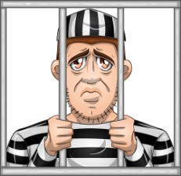 | C | injury   | D | shopping   | E | hero  
F | 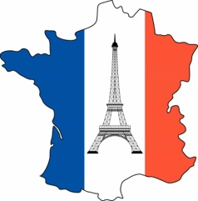  France | G | 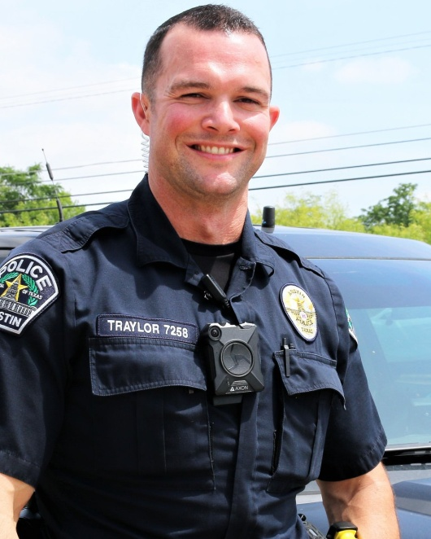  police officer | H | 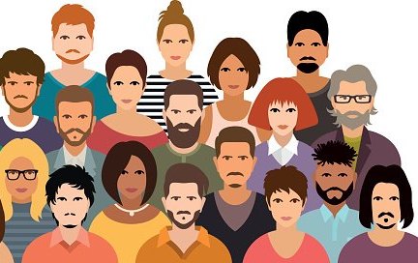  people | I | 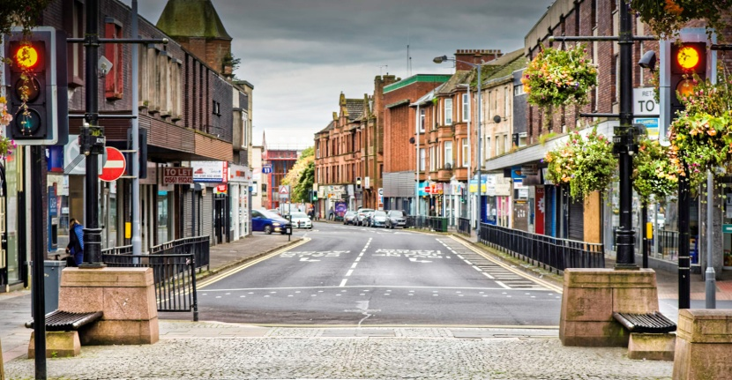  town | J  building | 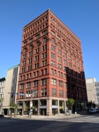

When I need some new clothes, I go __________ in the nearby mall.
A ________ tried to help people during the supermarket attack.
The _________ was sent to prison.
There are many offices in this tall __________.
She couldn’t walk because of the ____________ in her leg.
Doctors work at a ___________.
My dad is my ____________. He can save me from anything!
__________ is a beautiful country.
There were many _____________ in the supermarket when the attack took place.
I was born in a small ____________ of Greece.

