ΘΕΜΑ 1. ΚΑΤΑΝΟΗΣΗ ΓΡΑΠΤΟΥ ΛΟΓΟΥ
Read the text and decide if each statement (1-10) is True (A) or False (B).
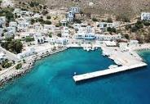
Tilos, the island of white houses, pink flowers and lots of goats is famous because it welcomes people from Syria. Greek people who live on Tilos are friendly. They give jobs to 12 families from Syria. Syrian men work at shops, tavernas and the island’s bakery. Syrian mothers stay with their children. The Syrian families live in a refugee camp in LIvadia, the island’s port. They live in simple houses, but the place has a lot of trees and the children can play and run around. The children will go to school in September. “I like the lessons, and playing outside, and having my friends around” said Nour, an eight-year-old Syrian girl. In other parts of Greece, people from Syria and Afghanistan have nothing to do and feel unhappy. There are more than 60,000 refugees in Greece who want to move to other countries.

Statements |  | A | B
 |  | TRUE | FALSE
 | There are many pink houses on Tilos.
 | There are a lot of donkeys on Tilos.
 | On Tilos, Greek people do not like Syrian people.
 | There are twelve families from Syria on Tilos these days.
 | On Tilos, Syrian women work at tavernas.
 | On Tilos, Syrian men work as teachers.
 | Syrian families live in expensive hotels.
 | Nour is a Greek girl.
 | There are many trees in the refugee camp.
 | Children can play in the refugee camp.

ΘΕΜΑ 2^{α}. ΛΕΞΙΚΟΓΡΑΜΜΑΤΙΚΗ
Match each picture below (11-20) with a word from the box (A-J). Use each word only once.
A. | run | B. | island | C. | goat | D. | shop | E. | taverna
F. | people | G. | camp | H. | flower | I. | port | J. | bakery

 | 
 | 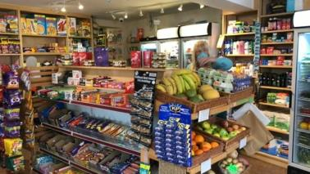
 | 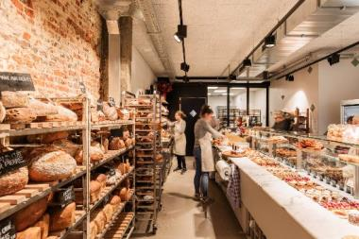
 | 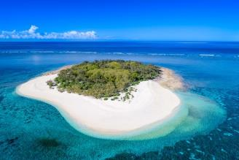
 | 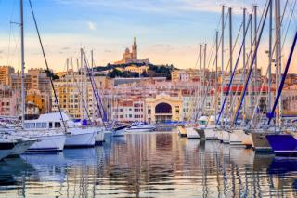
 | 
 | 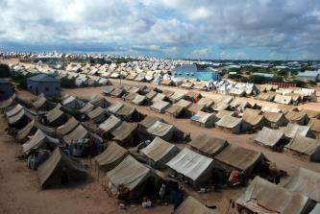
 | 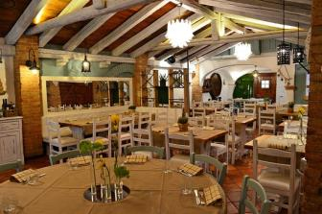
19. | 
20. | 