ΘΕΜΑ 1. ΚΑΤΑΝΟΗΣΗ ΓΡΑΠΤΟΥ ΛΟΓΟΥ
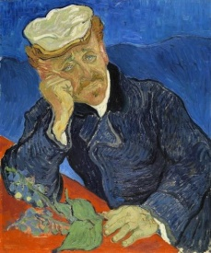
Read the text and decide if each statement (1-10) is True (A) or False (B).
In ten years Van Gogh painted around 900 paintings. His works show passion in colour and lines and his fight against madness and sadness. He was very sad and he wanted to show his feelings in his paintings. Many artists liked the work of Van Gogh and tried to paint like him. Vincent’s brother’s wife collected Van Gogh’s paintings and letters to his friends after his death. This is how Van Gogh became famous. Now many of his paintings are very expensive. Van Gogh's painting “Irises” was sold for a record $53.9 million in New York. His “Portrait of Doctor Gachet” was sold for $82.5 million.

Statements |  | A | B
 |  | TRUE | FALSE
 | Van Gogh painted about 900 paintings.
 | Van Gogh wanted to show how he felt in his paintings.
 | Van Gogh was fighting with madness.
 | Van Gogh was a very happy person.
 | Other artists liked Van Gogh’s paintings.
 | Van Gogh’s brother collected his paintings after his death.
 | Van Gogh wrote letters to his friends.
 | The painting ‘’Irises’’ was sold in Paris.
 | The painting ‘’Irises’’ was sold for $82.5 million.
 | The ‘’Portrait of Doctor Gachet’’ was sold for $53.9 million.

ΘΕΜΑ 2^{α}. ΛΕΞΙΚΟΓΡΑΜΜΑΤΙΚΗ
Fill each gap in sentences 11-20 with the correct word from the box below (A-J). Use each word only once.
A | sad   | B | friend   | C | painting   | D | portrait  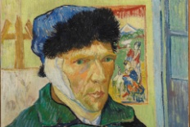 | E | doctor  
F |   paint | G |   letters | H |   line | I |   artist | J |   irises

Mary is my best _________; we do everything together!
She likes to ________ and she is taking art lessons at the moment.
When I am __________, I feel like crying.
This __________ shows a woman with some fruit.
Van Gogh made a self- ____________ when he cut his own ear.
I will take my son to the ____________ because he is sick.
The postman brought some ____________ today.
A painter is an __________.
Draw a _____________ under your name!
There are many ____________in our garden these days; they are so beautiful flowers!

