ΘΕΜΑ 1. ΚΑΤΑΝΟΗΣΗ ΓΡΑΠΤΟΥ ΛΟΓΟΥ
Read the text and decide if each statement (1-10) is True (A) or False (B).
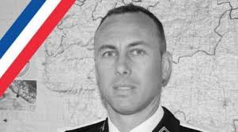
Christian Guibbert, a former police officer, was shopping in a Super U supermarket when he heard shots. It all happened near a quiet town of 5,000 people in France. At about 11:00 last Friday morning, a man of 25 walked into the supermarket shouting “Allahu Akbar”. Around 50 people were inside the building. The criminal killed one supermarket worker and one customer. The criminal, called Radouane Lakdim, was born in Morocco and lived in Carcassonne. He had spent some time in prison for small crimes in 2015. The supermarket attack lasted just over three hours. Lakdim was holding many people inside the supermarket. A police officer called Arnaud Beltrame offered to take the people’s place. Lakdim shot the officer and Beltrame died from his injuries a day later. The police officer was a real hero!

Statements |  | A | B
 |  | TRUE | FALSE
 | Arnaud Beltram was shopping in the supermarket.
 | The supermarket was near a big city.
 | The criminal was called Arnaud Beltrame.
 | The criminal was 45 years old.
 | Radouane Lakdim was born in Carcassonne.
 | The criminal went into the supermarket shouting.
 | The criminal had never been to prison before.
 | The supermarket attack lasted one hour.
 | Arnaud Beltrame died on a Saturday morning.
 | Arnaud Beltrame was a hero.

ΘΕΜΑ 2^{α}. ΛΕΞΙΚΟΓΡΑΜΜΑΤΙΚΗ
Match each underlined word/phrase in the sentences below (11-20) with a picture from the box (A-J). Use each picture only once.
A |  | B |  | C |  | D |  | E | 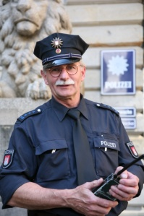
F |  | G |  | H | 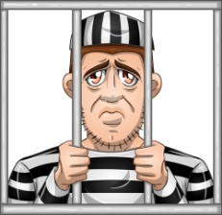 | I |  | J | 

Superman is a famous hero.
There are many people in the supermarket at the moment.
She went to the supermarket to buy some things.
A town is smaller than a city.
My mum was injured while cooking.
We heard a loud noise and got scared!
I like going shopping with my friends.
A police officer protects people.
The criminal killed two people.
When you build a house, you need a lot of workers.

