ΘΕΜΑ 1. ΚΑΤΑΝΟΗΣΗ ΓΡΑΠΤΟΥ ΛΟΓΟΥ
Read the text and decide if each statement (1-10) is True (A) or False (B).
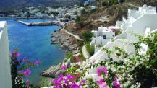
You can find Tilos in the Aegean sea near Turkey. Tilos is a beautiful island with white houses, pink flowers and goats, lots of goats. There is an old cave where people found the bones of very small elephants. The island became famous for that! But now, Tilos is known because is a place where families from Syria can live and be happy. Megalo Horio is the biggest town of Tilos. There 12 families from Syria stay at simple houses near the sea. The people on Tilos are very friendly. They give work to these 70 people from Syria at restaurants, shops and hotels. Syrians live with Greek people and they are not sad. Other Greek islands can do the same! More than 60,000 people from Syria, Iraq, Afghanistan and other countries want to have a home, work and live a better life in Greece and other countries.

Statements |  | A | B
 |  | TRUE | FALSE
 | Tilos is an island in the Aegean sea.
 | In the past, very big elephants lived on Tilos.
 | Tilos is far from Turkey.
 | The people on Tilos help people from Syria.
 | The people from Syria have found jobs on Tilos.
 | Megalo Chorio is an empty town nowadays.
 | Only men from Syria live in Megalo Chorio.
 | 60,000 people from Syria and Afghanistan live on Tilos.
 | On Tilos, the people from Syria are sad.
 | The people from Syria live in the biggest town of Tilos.

ΘΕΜΑ 2^{α}. ΛΕΞΙΚΟΓΡΑΜΜΑΤΙΚΗ
Fill each gap in sentences 11-20 with the correct word from the box below (A-J). Use each word only once.
A | flower  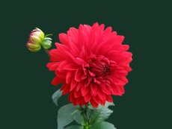 | B | sad   | C | men   | D | hotel   | E | goat  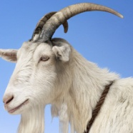
F |   restaurant | G |   cave | H | 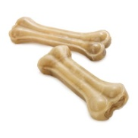  bones | I |   family | J | 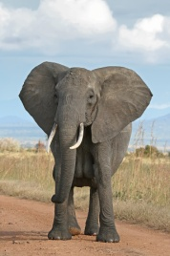  elephant

There is a beautiful red _________ in our garden.
My friends and I found a ________ in the mountain and we went inside to explore it.
Dogs like eating __________.
In Africa you could see an __________
My ____________ lives in a nice house near the sea.
Many____________ like to wear jeans these days.
Yesterday we went to a nice ____________ to have dinner.
There is a new __________ in our town. Many tourists stay there during their vacations.
When I am _____________, I want to be alone.
We could see a white ____________ in the farm.

