ΘΕΜΑ 1. ΚΑΤΑΝΟΗΣΗ ΓΡΑΠΤΟΥ ΛΟΓΟΥ
Read the text and decide if each statement (1-10) is True (A) or False (B).
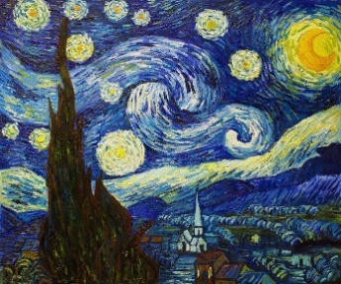
Van Gogh had a nervous character and he was a difficult friend. Near the end of 1988, he had a serious fight with his friend, Gaugin. After that, he was ill. He finally went to an asylum in Saint-Remy because he was very sad. He spent much time in the asylum and he painted some 150 paintings. He painted his most famous work “The Starry Night” there. The only painting he ever sold, ‘The Red Vineyard’, was created in 1888. In May 1890, Vincent van Gogh left the clinic and went to the doctor Paul Gachet, near Paris. At that time Van Gogh created the portrait of the melancholic “Dr. Gachet”, his doctor. At the age of 37, Van Gogh shot himself.

Statements |  | A | B
 |  | TRUE | FALSE
 | Vincent van Gogh was a quiet person.
 | It was easy for his friends to be with Vincent van Gogh.
 | Van Gogh had a big fight with his friend, Pablo Picasso.
 | Van Gogh went to an asylum because he was happy.
 | The asylum was in Saint-Remy.
 | In the asylum, Van Gogh did not paint at all.
 | Van Gogh sold two of his paintings during his life.
 | ‘’The Starry Night’’ is Van Gogh’s most famous painting.
 | Van Gogh painted ‘’The Red Vineyard’’ in 1888.
 | ‘’Doctor Gachet’’ was the portrait of his doctor.

ΘΕΜΑ 2^{α}. ΛΕΞΙΚΟΓΡΑΜΜΑΤΙΚΗ
Match each picture below (11-20) with a word from the box (A-J). Use each word only once.
A. | vineyard | B. | ear | C. | sad | D. | painting | E. | fight
F. | friend | G. | paint | H. | piece | I. | cut | J. | nervous

 | 
 | 
 | 
 | 
 | 
 | 
 | 
 | 
19. | 
20. | 

