ΘΕΜΑ 1. ΚΑΤΑΝΟΗΣΗ ΓΡΑΠΤΟΥ ΛΟΓΟΥ
Read the text and decide if each statement (1-10) is True (A) or False (B).
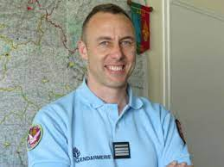
In Carcassonne, southern France, a police officer died last Saturday morning. Just after 10am last Friday, Radouane Lakdim, 25, a Moroccan who lived in Carcassonne, stopped a white Opel Corsa car. The criminal shot and killed a person in the car and seriously hurt the driver. Then he drove off to a police office building and started shooting at four officers who were jogging. He finally drove to a supermarket in Trebes, a town near Carcassonne. At about 11am, he walked into the shop shouting Allahu Akbar. Then Lakdim killed one supermarket worker and one customer. Policemen tried to take the people out of the supermarket. A police officer offered to take the people’s place. The gunman agreed. The police officer, named Arnaud Beltrame, went into the supermarket and left his mobile phone line open on a table. Policemen heard a shot and they ran into the supermarket. They killed the criminal but found Arnaud Beltrame seriously injured.

Statements |  | A | B
 |  | TRUE | FALSE
 | Arnaud Beltrame was a police officer.
 | Arnaud Beltrame died on a Friday morning.
 | Arnaud Beltrame was French.
 | The criminal’s name was Radouane Lakdim.
 | Radouane Lakdim was 25 years old.
 | The white Opel Corsa was Lakdim’s car.
 | The supermarket is located in Trebes.
 | Lakdim tried to take people out of the supermarket.
 | Arnaud Beltrame left his mobile phone on a table.
 | Arnaud Beltrame killed Lakdim.

ΘΕΜΑ 2^{α}. ΛΕΞΙΚΟΓΡΑΜΜΑΤΙΚΗ
Match each underlined word in the sentences below (11-20) with a picture from the box (A-J). Use each picture only once.
A | 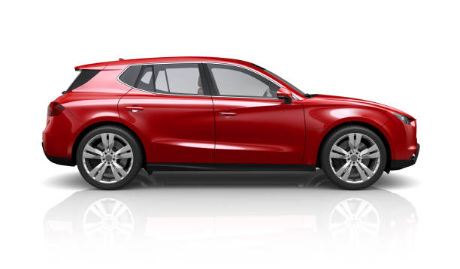 | B | 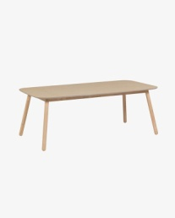 | C | 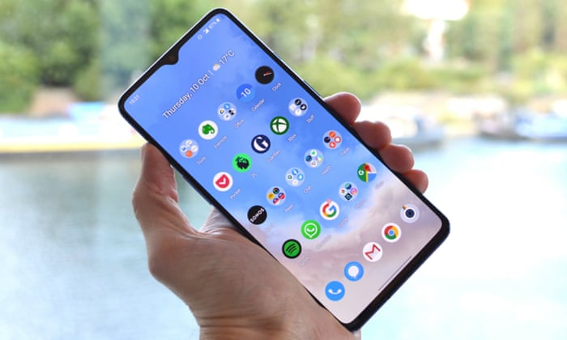 | D | 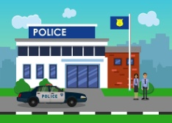 | E | 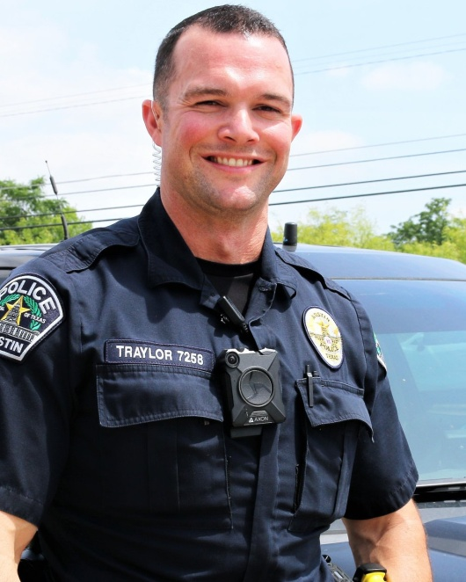
F | 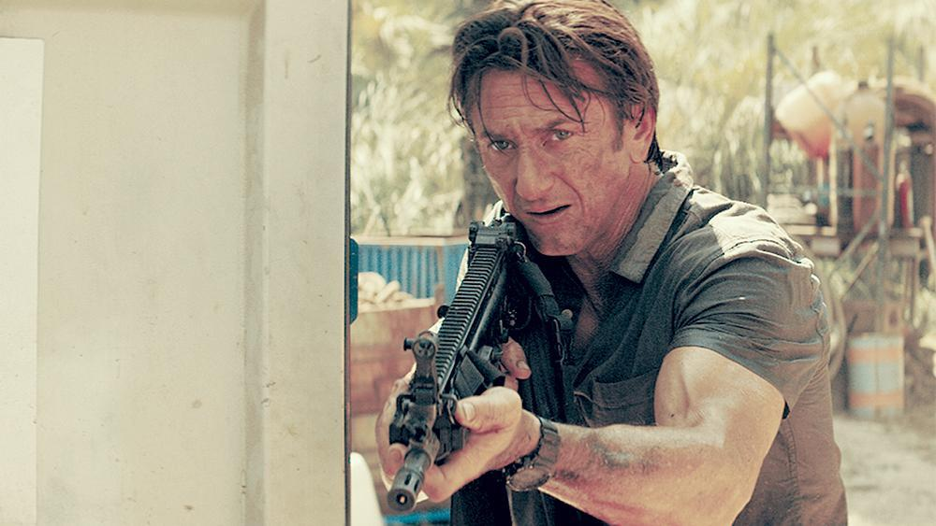 | G | 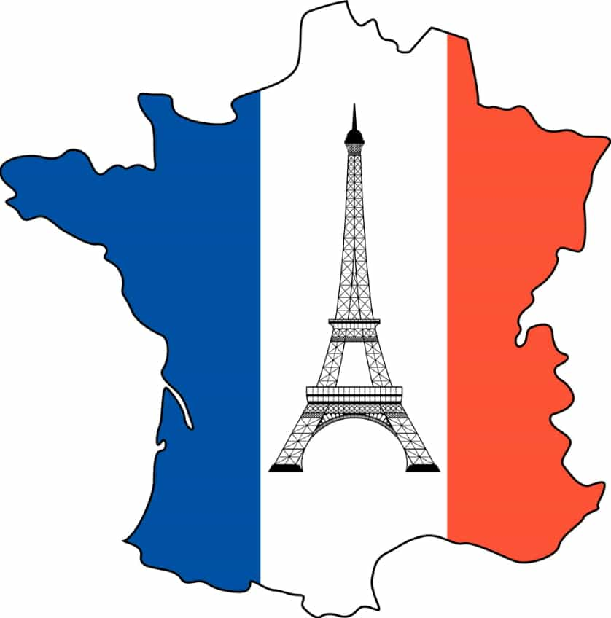 | H | 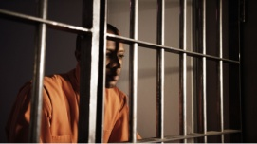 | I | 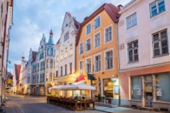 | J | 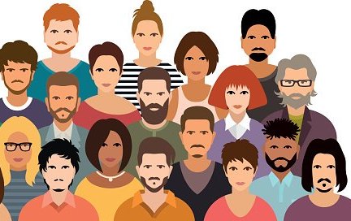

The gunman shot a customer at the supermarket.
There are a lot of people in this photo.
The Greek police caught the criminal last night.
The Eiffel Tower is in France.
I would like to become a police officer and help people.
I have to take my car to the mechanic.
To get a new ID card, you have to go to a police station.
My mum is talking on her mobile phone at the moment.
We can go shopping in the town.
We have a very big table in the living room.

