ΘΕΜΑ 1. ΚΑΤΑΝΟΗΣΗ ΓΡΑΠΤΟΥ ΛΟΓΟΥ
Read the text and decide if each statement (1-10) is True (A) or False (B).
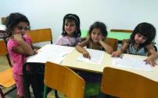
Tilos is a place where families from Syria can live and be happy. The people on Tilos are very friendly. They give work to people from Syria at restaurants, shops and hotels. Other Greek islands can do the same!
The children will go to schools on the island in September. “I like the lessons, and playing outside, and having my friends around,” said Nour, an eight-year-old Syrian girl. Eleni Kymina is a Greek teacher. “The kids really want to learn, they want to play.” the teacher said. The families from Syria are happy because they have a job. They can live anywhere on the island. The kids go to the playground and they swim in the sea. And they learn Greek quickly.

Statements |  | A | B
 |  | TRUE | FALSE
 | Tilos is not an island.
 | Many Greek families from Athens have moved to Tilos.
 | The people on Tilos are kind to people from Syria.
 | The people from Syria cannot find a job on Tilos.
 | The people from Syria work as teachers on the island.
 | The children from Syria cannot go to school on Tilos.
 | On Tilos, the people from Syria are sad.
 | On Tilos, the people from Syria cannot live in the town.
 | Elena Kymina is a Syrian teacher.
 | The children from Syria can play and swim.

ΘΕΜΑ 2^{α}. ΛΕΞΙΚΟΓΡΑΜΜΑΤΙΚΗ
Fill each gap in sentences 11-20 with the correct word from the box below (A-J). Use each word only once.
A | school   | B | work   | C | girl   | D | hotel   | E | play  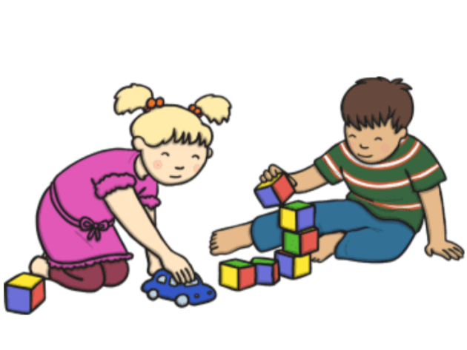
F |   kids | G |   swim | H |   happy | I |   teacher | J |   sad

My best friend is a very beautiful _________
Students start ________ at 8:15 in the morning.
At school __________ learn how to read and write.
He knows how to __________ very well. He goes to a swimming pool every day.
I love my ____________! She is very kind to all her students!
My little brother loves to ____________ with his friend, Emma.
My sister Kate is very ____________ today. She has got her birthday!
Our __________ was really nice! We loved staying there during our summer holidays!
He was crying because he was very _____________.
My father is not at home at the moment. He is at ____________

