ΘΕΜΑ 1. ΚΑΤΑΝΟΗΣΗ ΓΡΑΠΤΟΥ ΛΟΓΟΥ
Read the text and decide if each statement (1-10) is True (A) or False (B).
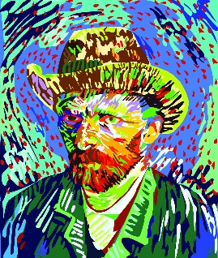
In spring 1886, Vincent van Gogh went to Paris with his brother Theo. They stayed at a house in Montmartre. In Paris van Gogh met the painters Edgar Degas, Camille Pissarro, Bernard, Henri de Toulouse-Lautrec and Paul Gauguin. He liked how these painters used light and colour. Especially he liked painting with many small dots. Van Gogh used colour and lines to show his feelings. Van Gogh was, also, a nervous person. He went to Arles, to make a school of art. Gauguin went with him but after a big fight with Van Gogh, he had to leave Arles. Van Gogh cut a piece of his own ear during that fight.

Statements |  | A | B
 |  | TRUE | FALSE
 | In 1886, Van Gogh and his brother went to Paris.
 | Van Gogh’s brother was called Theo.
 | In Paris Van Gogh met Pablo Picasso.
 | In Paris Van Gogh met Paul Gauguin.
 | Van Gogh liked other artists’ work.
 | Van Gogh did not like painting with dots.
 | Van Gogh wanted to create a school of cooking in Arles.
 | Gauguin went to Arles with Van Gogh.
 | Gauguin never left Arles.
 | During a fight, Van Gogh cut a piece of Gauguin’s ear.

ΘΕΜΑ 2^{α}. ΛΕΞΙΚΟΓΡΑΜΜΑΤΙΚΗ
Match each picture below (11-20) with a word/phrase from the box (A-J). Use each word/phrase only once.
A. | Paris | B. | painter | C. | brother | D. | dot | E. | light
F. | school | G. | piece | H. | ear | I. | flowers | J. | cut

 | 
 | 
 | 
 | 
 | 
 | 
 | 
 | 
19. | 
20. | 

