ΘΕΜΑ 1. ΚΑΤΑΝΟΗΣΗ ΓΡΑΠΤΟΥ ΛΟΓΟΥ
Read the text and decide if each statement (1-10) is True (A) or False (B).

Arnaud Beltrame, a police officer, was shot during a French supermarket attack last Friday. The police killed the criminal. The criminal, named Radouane Lakdim, drove to a supermarket 8km away from Carcassonne in Trebes, a quiet town of 5,000 people. At about 11am on Friday morning, he walked into the shop shouting Allahu Akbar. Around 50 people were inside the building. Lakdim killed one supermarket worker and one customer. Police officers tried to take the people out of the supermarket. Lt Col Arnaud Beltrame, a police officer, wanted to take the people's place. The gunman agreed to that, so the police officer stayed with him while the rest of the people left. The police officer left his mobile phone line open on a table. Unfortunately, the criminal shot Arnaud Beltrame. Early on Saturday morning Beltrame died.

Statements |  | A | B
 |  | TRUE | FALSE
 | Arnaud Beltrame was a police officer.
 | Arnaud Beltrame was shot by a criminal.
 | Arnaud Beltrame killed the criminal.
 | The criminal’s name was Radouane Lakdim.
 | Lakdim drove to the city centre of a noisy town.
 | Lakdim was talking on his mobile phone during the attack.
 | Lakdim walked into the supermarket on a Saturday morning.
 | Arnaud Betrame did not get into the supermarket.
 | Beltrame stayed with the criminal in the supermarket.
 | Arnaud Beltram died on a Saturday morning.

ΘΕΜΑ 2^{α}. ΛΕΞΙΚΟΓΡΑΜΜΑΤΙΚΗ
Match each picture below (11-20) with a word/phrase from the box (A-J). Use each word/phrase only once.
A. | France | B. | gunman | C. | people | D. | police officer | E. | town
F. | supermarket | G. | car | H. | criminal | I. | building | J. | mobile phone

 | 
 | 
 | 
 | 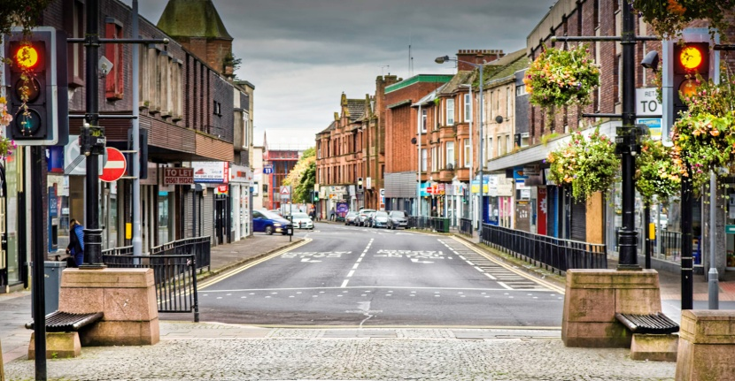
 | 
 | 
 | 
 | 
19. | 
20. | 