ΘΕΜΑ 1. ΚΑΤΑΝΟΗΣΗ ΓΡΑΠΤΟΥ ΛΟΓΟΥ
Read the text and decide if each statement (1-10) is True (A) or False (B).
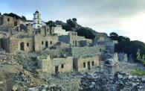
Similar to many other Greek islands, there are not many people living on Tilos. Up in the hills, away from the beaches, we can visit the empty village of Mikro Chorio. People left from Mikro Chorio after the Second World War and they went to Athens, the United States and Australia. Today, goats walk around the empty houses. Now, twelve families from Syria live on Tilos. They work at shops and restaurants on the island. There are, also, plans to build a cheese factory on Tilos by using the milk from the goats. Syrian and Greek people can work together in the factory. This factory can bring life back to Tilos.

Statements |  | A | B
 |  | TRUE | FALSE
 | Tilos is an island.
 | Many people live on Tilos.
 | Mikro Chorio is a noisy village.
 | Only goats live in Michro Chorio nowadays.
 | People lived in Michro Chorio before the Second World War.
 | People from Michro Chorio went to Athens after the Second World War.
 | Fifteen families from Syria live on Tilos nowadays.
 | Syrian people work on the island.
 | There are plans to build an oil factory on Tilos.
 | Syrian and Greek people will use donkey milk to make cheese.

ΘΕΜΑ 2^{α}. ΛΕΞΙΚΟΓΡΑΜΜΑΤΙΚΗ
Match each picture below (11-20) with a word from the box (A-J). Use each word only once.
A. | cheese | B. | island | C. | people | D. | shop | E. | village
F. | goat | G. | restaurant | H. | family | I. | factory | J. | milk

 | 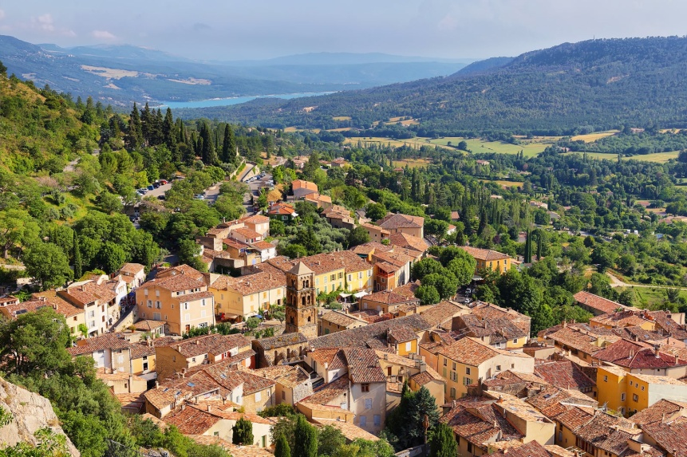
 | 
 | 
 | 
 | 
 | 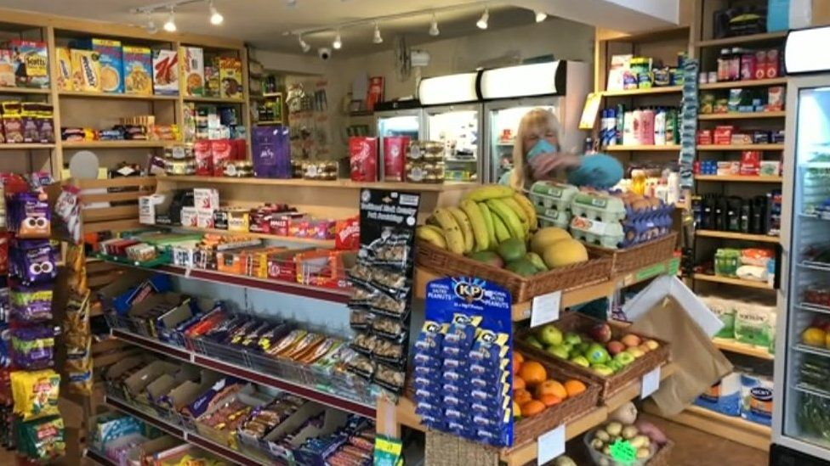
 | 
 | 
19. | 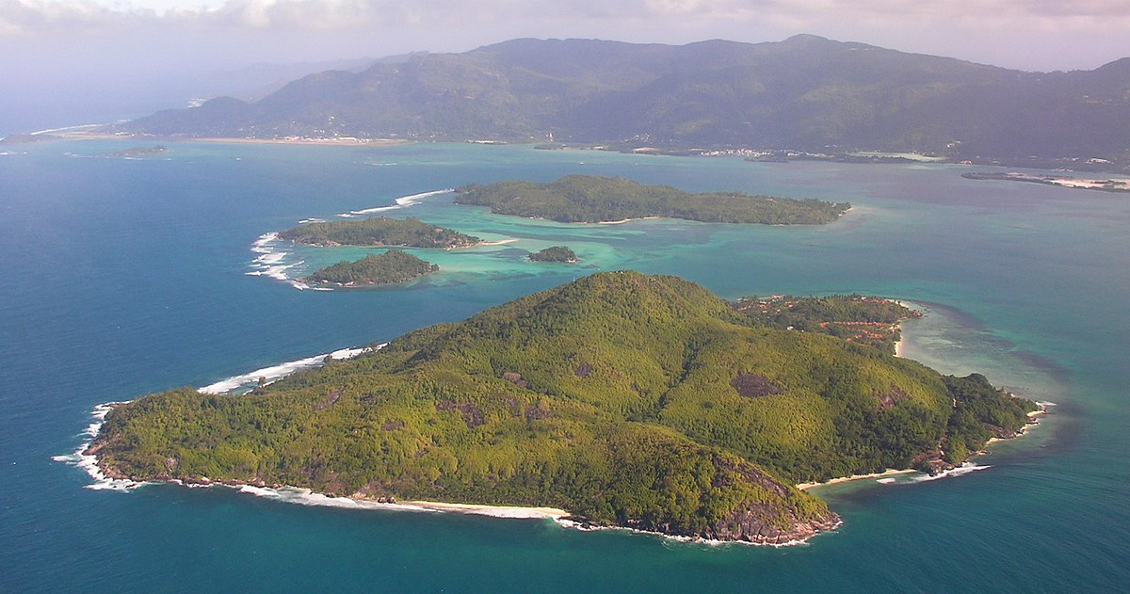
20. | 

