ΘΕΜΑ 1. ΚΑΤΑΝΟΗΣΗ ΓΡΑΠΤΟΥ ΛΟΓΟΥ
Read the text and decide if each statement (1-10) is True (A) or False (B).
Vincent van Gogh
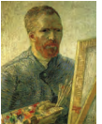
Vincent van Gogh was born in Holland. He was the son of a priest. His sister said that he was a serious and quiet child. In spring 1886 Vincent went to Paris. There he met famous painters, like Edgar Degas, Paul Gauguin, etc. Van Gogh was a nervous person, too. He went to Arles to create a school of art. Gauguin went with him but, after a serious fight, Van Gogh cut off a piece of his own ear. Van Gogh was sent to an asylum because he was ill and very sad. There he painted some 150 paintings. The only painting he sold was “The Red Vineyard’’. Finally, Van Gogh shot himself. He died two days later. Theo, his brother got very sad and died 6 months later. Vincent’s brother’s wife collected Vincent’s paintings and letters after his death. His portrait of “Doctor Gachet” was sold for $82.5 million.

Statements |  | A | B
 |  | TRUE | FALSE
 | Van Gogh was a painter.
 | Van Gogh was born in Italy.
 | Van Gogh’s father was a teacher.
 | Van Gogh was a noisy child.
 | In Paris Van Gogh met Paul Gauguin.
 | Van Gogh went to Arles with Gauguin.
 | Van Gogh wanted to create a school of art in Paris.
 | Van Gogh went to an asylum.
 | In the asylum Van Gogh painted only one painting.
 | When Van Gogh was alive, he sold many of his paintings.

ΘΕΜΑ 2^{α}. ΛΕΞΙΚΟΓΡΑΜΜΑΤΙΚΗ
Match each underlined word in the sentences below (11-20) with a picture from the box (A-J). Use each picture only once.
A |  | B | 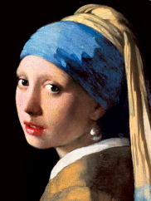 | C |  | D | 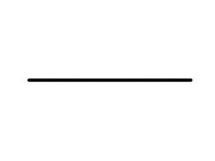 | E | 
F |  | G |  | H |  | I |  | J | 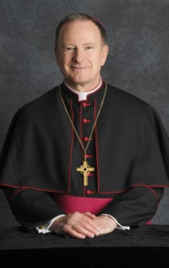

In spring, there are many flowers in the countryside.
She is married and has one child.
Bob Ross was a painter.
My ear hurts! I must take an aspirin!
The painter liked her face and he wanted to make her portrait.
She finished the painting last night.
He became a priest of the Roman Catholic Church.
I wrote a letter to my aunt yesterday.
Draw a line under your name!
He went to the doctor because he wasn’t feeling well.

