ΘΕΜΑ 1. ΚΑΤΑΝΟΗΣΗ ΓΡΑΠΤΟΥ ΛΟΓΟΥ
Read the text and decide if each statement (1-10) is True (A) or False (B).
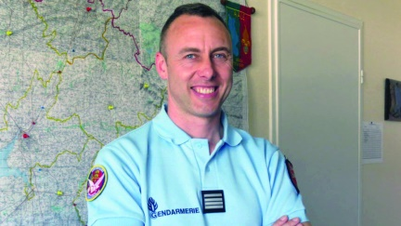
Arnaud Beltram, a police officer, died in hospital; last Saturday morning. He tried to save people from a criminal in a French supermarket. The criminal shot the police officer. Finally, the French police killed the criminal. The criminal, Radouane Lakdim, 25, was born in Morocco and lived in France. He was known to the police for small crimes. On Friday morning, Lakdim got a gun. Just after 10am on Friday morning, Lakdim stopped a white Opel Corsa car and hurt the driver. Lakdim took the car and shot four police officers who had been out jogging. He shot near one officer’s heart. Then, he drove to a supermarket.

Statements |  | A | B
 |  | TRUE | FALSE
 | Arnaud Beltram was a criminal.
 | Arnaud Beltram is dead.
 | The police officer killed the criminal.
 | The criminal’s name is Radouane Lakdim.
 | The criminal was 35 years old.
 | The criminal was born in France.
 | The criminal got a gun on Saturday morning.
 | Police officers killed the criminal.
 | The criminal stole a white car.
 | Arnaud Beltram was in the supermarket when the criminal got in.

ΘΕΜΑ 2^{α}. ΛΕΞΙΚΟΓΡΑΜΜΑΤΙΚΗ
Match each underlined word in the sentences below (11-20) with a picture from the box (A-J). Use each picture only once.
A |  | B | 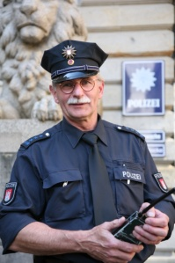 | C |  | D |  | E | 
F |  | G |  | H |  | I |  | J | 

My friend and I like jogging.
Doctors work in a hospital.
We go to the supermarket every Saturday.
Paris is in France.
The criminal hurt the police officer with a gun.
The driver of the school bus is very kind.
A policeman helps people.
She drew a heart on her letter.
The police caught the criminal.
My car is new and fast.

