ΘΕΜΑ 1. ΚΑΤΑΝΟΗΣΗ ΓΡΑΠΤΟΥ ΛΟΓΟΥ
Read the text and decide if each statement (1-10) is True (A) or False (B).
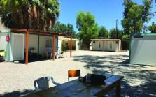
Tilos, an island of the Aegean Sea near Turkey, welcomes people from Syria. Twelve families from Syria now live on the island with 500 Greek people. This is very important! In other places in Greece, people from Syria live a very difficult life and they cannot work. But on Tilos they can work in hotels, restaurants and shops.
On Tilos they live in the town near tavernas and the sea. Their houses are simple, but the place has a lot of trees and children can play and run around. It is better to live on Tilos than on other islands such as Lesbos and Chios. On other islands, men, women and children from Syria feel very sad and they want to leave to other countries.

Statements |  | A | B
 |  | TRUE | FALSE
 | Tilos is an island.
 | Tilos is in the Ionian Sea.
 | Tilos is near Turkey.
 | People from Syria are welcome in Tilos.
 | 200 Greek people live on Tilos.
 | In other places of Greece, people from Syria have a job.
 | On Tilos, people from Syria work at schools.
 | On Tilos, people from Syria do not live close to the town.
 | People from Syria feel happy on Lesbos and Chios.
 | People from Syria want to live on Lesbos and Chios forever.

ΘΕΜΑ 2^{α}. ΛΕΞΙΚΟΓΡΑΜΜΑΤΙΚΗ
Match each underlined word/phrase in the sentences below (11-20) with a picture from the box (A-J). Use each picture only once.
A | 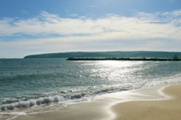 | B |  | C | 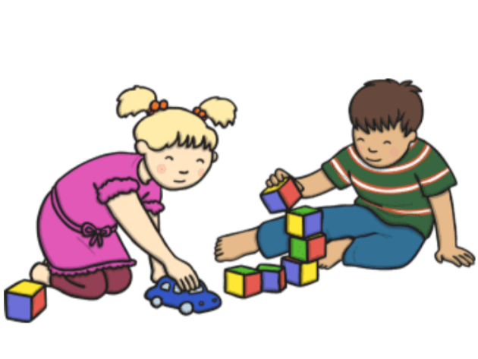 | D |  | E | 
F |  | G | 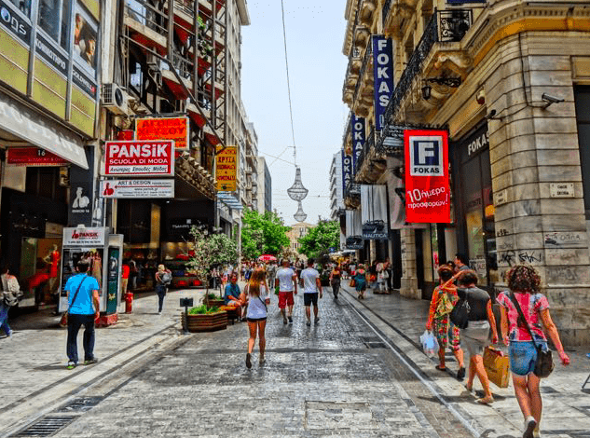 | H |  | I |  | J | 

My father is at work at the moment.
Santorini is an amazing Greek island.
In summer, we go swimming in the sea.
Children learn a lot of new things at school.
We can go shopping in the center of a town.
When I am sad, I want to be alone.
Children like playing with toys.
We go to school every day from Monday to Friday.
My house is my castle!
When I am happy, I feel like singing.

