ΘΕΜΑ 1. ΚΑΤΑΝΟΗΣΗ ΓΡΑΠΤΟΥ ΛΟΓΟΥ
Read the text and choose the correct option (A or B) for items 1-10.

Maria: Hi! Good to see you Gina!
Gina: Hi! Where have you been this summer?
Maria: Oh, there’s so much to tell you.
George: Hi, girls! You look fine!
Girls: Hi, George. Nice to see you again.
Gina: Where did you get that super T-shirt?
Maria: What’s that on your T-shirt? Let me see.
George: It’s my favourite rock band! They are amazing!
Nick: Hey, hey! Here I am.
Elena: You said you were going to Senior High School, Nick.
Nick: That was my plan. Then, I went to my uncle’s farm this summer. That changed it all. I’m going to work with him on the farm. That’s why I chose EPAL. I like farms but I need to learn everything about farms.
Tony: Hi, guys!
Gina and Nick: Hi! Who are you?
Tony: I’m Tony. I’m new here.
Gina: Where are you from?
Tony: I’m not from Athens, I’m from Kastro.
Gina and Nick: Fine. Nice to meet you, Tony. Join us then.

Statements |  | A | B
 |  | TRUE | FALSE
 | Maria and Gina are friends.
 | Gina and George are not friends.
 | George is wearing a T-shirt.
 | There is a on George’s T-shirt
 | George’s uncle has got a farm.
 | George does not like farms.
 | Tony is a new student.
 | Gina and Nick are Tony’s friends.
 | Tony is from Athens.
 | Gina and Nick tell Tony to go with them.

ΘΕΜΑ 2^{α}. ΛΕΞΙΚΟΓΡΑΜΜΑΤΙΚΗ
Fill each gap in sentences 11-20 with the correct word/phrase from the box below (A-J). Use each word only once.
A | school   | B | work   | C | student  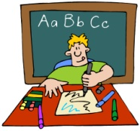 | D | horse  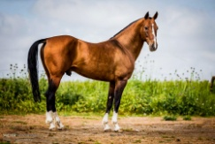 | E  farmer | 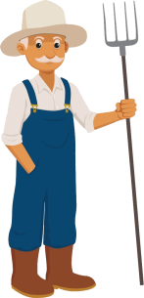
F |   summer | G |   T-shirt | H |   friends | I |   rock band | J  mobile phone | 

My friend, Anna, can ride a _________
Students start ________ at 8:15 in the morning.
At school a __________ learns how to read and write.
I am wearing a blue __________ today.
I love rock music! This is my favourite _________ !
I am trying to call her, but her ____________ is not working.
My sister and Kate are very good ____________. They love each other a lot.
I love the sunny weather. I prefer _________ to winter.
George’s uncle has a farm. He is a ____________
My father is not at home now. He is at ____________

