ΘΕΜΑ 1. ΚΑΤΑΝΟΗΣΗ ΓΡΑΠΤΟΥ ΛΟΓΟΥ
Read the text and decide if each statement (1-10) is True (A) or False (B).
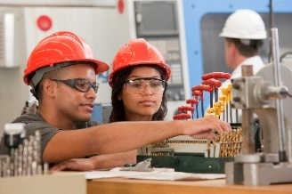
People can learn new things all over their lives, but boys and girls must go to school up to the age of 15. In Greece, students cannot stop classes before this age but they don’t have to go school after the age of 15. When students finish Junior High School, which usually happens at the age of 15 they can stop school, they can go to a Senior High School or they can go to a Vocational High School (EPAL). Sometimes students at Senior High School can change school and go to an EPAL. Almost every town has a Senior High School. In EPAL students learn practical things about technical jobs, for example the job of a mechanic. Only cities and big towns have an EPAL. Also, not every EPAL has teachers for all technical jobs. Students may have to go to an EPAL far from their houses if they want to learn about the job they like.

Statements |  | A | B
 |  | TRUE | FALSE
 | There are different types of schools in Greece.
 | In Greece, all boys must stop school at the age of 15.
 | All Greek children must go to Senior High School.
 | In Greece, a 10-year-old child can stop school.
 | Senior High Schools and EPAL Schools are exactly the same.
 | Students can choose if they want to go to an EPAL school.
 | If you want to become a mechanic, you can go to an EPAL school.
 | Students who like technical jobs can go to an EPAL school.
 | There are many EPAL schools in small villages.
 | Students can go to an EPAL school far from their houses.

ΘΕΜΑ 2^{α}. ΛΕΞΙΚΟΓΡΑΜΜΑΤΙΚΗ
Match each underlined word in the sentences below (11-20) with a picture from the box (A-J). Use picture only once.
A | 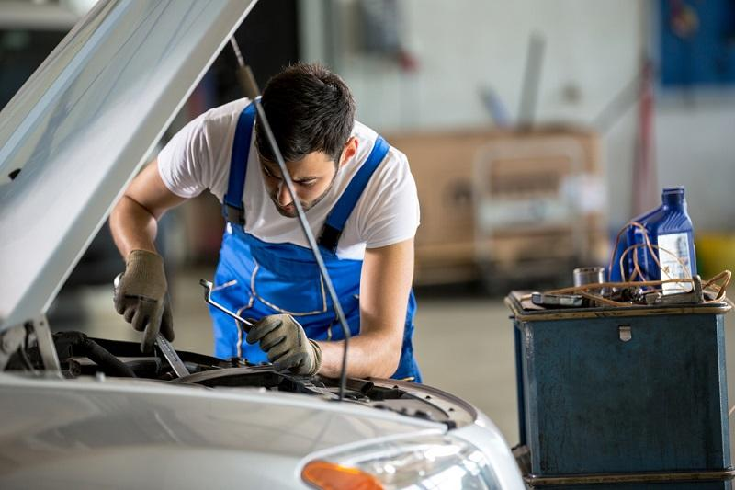 | B | 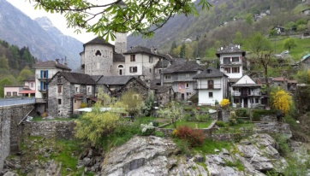 | C |  | D |  | E | 
F |  | G |  | H |  | I | 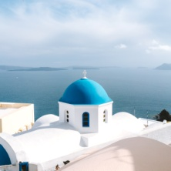 | J | 

My grandparents live in a small village.
Parents love their children.
Students learn to read and write.
There is one school in the village.
My father will go to the doctor because he feels sick.
A child needs to play all the time.
When you see the red sign, stop!
My cousin lives on an island.
John wants to run fast and finish first.
When I finish EPAL, I will become a car mechanic.

