ΘΕΜΑ 1. ΚΑΤΑΝΟΗΣΗ ΓΡΑΠΤΟΥ ΛΟΓΟΥ
Read the text and decide if each statement (1-10) is True (A) or False (B).

The history of post
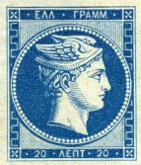
Hermes was the first ‘postman-god’. In mythology, Hermes was the son of Zeus and Maia. He brought luck, money and sleep to people. He was the postman of the gods living on Olympus Mountain, too. He brought gods’ messages to gods and people. You could see his head on Greek stamps of the past. People made the first stamps when they made modern paper. This is when people started to learn how to read and write. In earlier times, only the rich people sent messages. People wrote the letters on the skin of a sheep and tablets. Egyptians, Greeks and Romans used papyrus. In 1840 people made the first stamp. Its name was ‘penny black’ because it cost a penny. The person who made it was Sir Rowland Hill. People used the first postcards around 1870. Post offices took letters to people’s houses.

Statements |  | A | B
 |  | TRUE | FALSE
 | Hermes was the first Greek “postman”.
 | Hermes was the son of Zeus.
 | Hermes brought bad luck to people.
 | In the past, only rich people sent messages.
 | People put stamps on the skin of a sheep.
 | Egyptians, Greeks and Romans used papyrus.
 | In 1840 people made the first stamp.
 | The name of the first stamp was Sir Rowland Hill.
 | The first stamp cost a euro.
 | In 1870 people used the first postcards.

ΘΕΜΑ 2^{α}. ΛΕΞΙΚΟΓΡΑΜΜΑΤΙΚΗ
Match each of the underlined words below (11-20) with a picture from the box (A-J). Use each picture only once.
A | 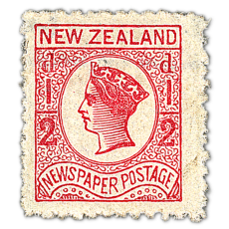 | B |  | C |  | D |  |  | E | 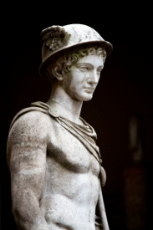
F | 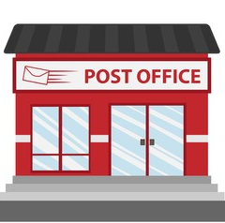 | G | 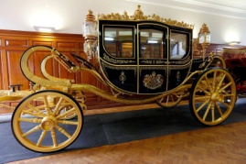 | H | 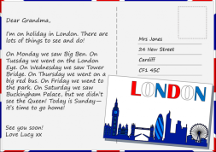 | I | 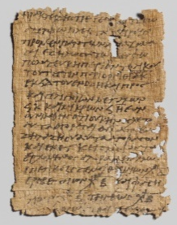 | J |  | 

11. | The house of a King and a Queen is called a castle.
12. | A stamp is a small piece of paper that you buy and stick on a letter.
13. | Egyptians used it to write on papyrus.
14. | You go to the post office to send a letter.
15. | Hermes was the first ‘’postman-God’’.
16. | You need money to buy things.
17. | People live in a city.
18. | In the past, people used a coach to go from town to town.
19. | A King lived in a castle.
20. | A postcard is a card usually with a picture of a place on it.

