ΘΕΜΑ 1. ΚΑΤΑΝΟΗΣΗ ΓΡΑΠΤΟΥ ΛΟΓΟΥ
Read the text and decide if each statement (1-10) is True (A) or False (B).

The history of post
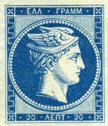
Hermes was the first ‘postman-god’. In mythology, Hermes was the son of Zeus and Maia. He brought the dead people to Hades. He also brought luck, money and sleep to people. He was the postman of the gods living on Olympus Mountain, too. He brought the gods’ messages to gods and people. You could see his head on Greek stamps of the past.
People made the first stamps when they made modern paper. This is when people started to learn how to read and write. In earlier times, only the rich people sent messages. People wrote the letters on the skin of a sheep and tablets. Egyptians, Greeks and Romans used papyrus. People made modern paper in England. Horses and guides brought the letters from London to towns and villages of the country. The King had this post. Of course he could read the letters!

Statements |  | A | B
 |  | TRUE | FALSE
 | Hermes was the father of Zeus.
 | Maia was the sister of Hermes.
 | Hermes was the postman of the gods.
 | The gods lived on Olympus Mountain.
 | Hermes brought luck to people.
 | Hermes helped people sleep.
 | You could see Hermes’ eyes on stamps of the past.
 | In the past, people wrote on the skin of a sheep.
 | Egyptians wrote on papyrus.
 | People in Greece were the first to use modern paper.

ΘΕΜΑ 2^{α}. ΛΕΞΙΚΟΓΡΑΜΜΑΤΙΚΗ
Match each underlined word in the sentences below (11-20) with a picture from the box (A-J). Use each picture only once.
A. | 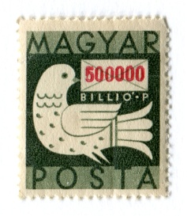 | B. |  | C. |  | D. | 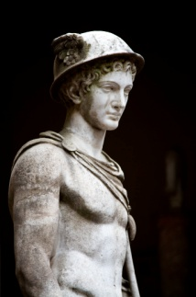 | E. | 
F. |  | G. |  | H. | 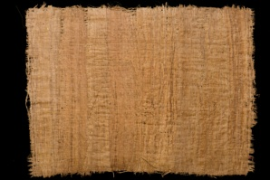 | I. |  | J. | 

I live in a big town.
My brother loves horses.
The King could read the letters.
You can write on a piece of paper.
This is a very old stamp.
Hermes was the first postman-god.
Many people live in my town.
Sheep live in a farm.
Greeks and Egyptians wrote letters on papyrus.
A postman brings letters to people.

