ΘΕΜΑ 1. ΚΑΤΑΝΟΗΣΗ ΓΡΑΠΤΟΥ ΛΟΓΟΥ
Read the text and decide if each statement (1-10) is True (A) or False (B).

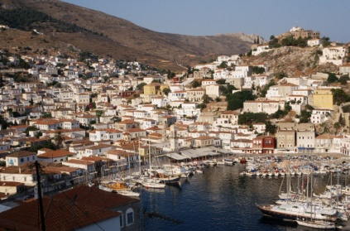
Hydra is a small island in the Argosaronic Gulf. Although Hydra is a name that means a place with plenty of water, Hydra is dry and rocky. Since farming was impossible, the island could not offer much to make a living. As a result, the people who first came to live on the island started building ships. For the same reason, when the Turks took over Hydra in 1715, they paid no attention to its dry land. The clever Hydriots then built up an important number of ships, which finally made up two-thirds of the whole Greek Sea Force. The Hydriots joined the Greek War of Independence against the Turks in 1821. Two of the most important men who fought in the Greek Revolution came from Hydra. The first one was Andreas Miaoulis, who gave commands to all the Greek ships. The second one was Georgios Koundouriotis, who was the first Prime Minister of the newly born Greek State from 1822 to 1827.
If you go to Hydra, you must visit the Museum of Hydra. Hydrian costumes, objects from the War of Independence and paintings of the ships of the 1821 Greek Revolution are on display there. More importantly, Miaoulis’ heart, the heart of Greece, is “alive” in the Hall of Paintings of the Museum of Hydra even today.
(Words: 219)

Statements |  | A | B
 |  | TRUE | FALSE
 | The text talks about what visitors can eat in Hydra.
 | Hydra is a dry island with no forests.
 | The island of Hydra is ideal for farming.
 | The first Hydriots came to live on the island in 1715.
 | The Hydriots didn’t let the Turks take over the island.
 | The Hydriots managed to build up many ships.
 | The Hydriot ships took part in the Greek War of Independence in 1821.
 | Georgios Koundouriotis served as a Greek governor.
 | At the Museum of Hydra, visitors can see Miaoulis’ last ship.
 | The Hall of Paintings is a place near the Museum of Hydra.

ΘΕΜΑ 2^{α}. ΛΕΞΙΚΟΓΡΑΜΜΑΤΙΚΗ
Fill each gap in sentences 11-20 with the correct word from the box below (A-J). Use each word only once.
A. | fighting | B. | finally | C. | reason | D. | objects | E. | dry
F. | clever | G. | plenty | H. | important | I. | rocky | J. | join

11. | He didn’t tell us the ____ why he didn’t want to come to the party.
12. | After thinking over it for some time I have ___ decided to apply for the position of the executive assistant.
13. | He is a student at university. He’s friendly, ____ and helpful at the same time.
14. | There’s ____ more juice in the fridge; you can drink as much as you like.
15. | I saw many things like dinosaur bones and various ____ from the past at the National History Museum.
16. | We had to walk across a rough, ____ path to reach the cave at the top of the mountain.
17. | He was one of the most ____ writers of his time; that’s why his novels are still taught at schools.
18. | We need ____ wood sticks to start a fire; these ones are very wet.
19. | He was a powerful man who spent his life ____ organized crime.
20. | I felt so tired after Christmas that I decided to ____ a gym in order to get stronger.

