ΘΕΜΑ 1. ΚΑΤΑΝΟΗΣΗ ΓΡΑΠΤΟΥ ΛΟΓΟΥ
Read the text and decide if each statement (1-10) is True (A) or False (B).

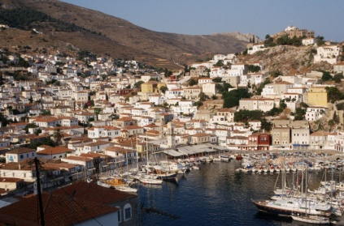
Situated at a short distance from the port of Piraeus, Hydra is one of the islands of the Argosaronic Gulf. People say that in the past Hydra was a place with a lot of forests. Although the name Hydra means a place with plenty of water, today the island is dry and rocky. As farming was impossible, the island could not offer much to make a living. As a result, the people who first settled on the island started building ships and they managed to build up a large number of ships, which developed into a merchant marine power. By the 19th century Hydra was rich, a great sea power and had become independent. The Hydriot ships were the only ships that could transport goods in the Mediterranean Sea.
The Hydriots were not the first to start the Greek War of Independence against the Turks in 1821. When they joined, however, their ships made up two-thirds of the whole Greek fleet. More than that, they offered their men to the Revolution. Admiral Andreas Miaoulis was the first commander of the Greek fleet. If you ever go to Hydra, you must visit the Museum of Hydra. There you can see Miaoulis’ cross and more importantly, his heart, the heart of Greece, in the Hall of Paintings.
(Words: 215)

Statements |  | A | B
 |  | TRUE | FALSE
 | The text talks about the island of Hydra and its history.
 | Hydra continues being a wet and green island in present days.
 | The first Hydriots had to grow plants in order to survive.
 | Before and during the Greek War of Independence the island was a great sea power.
 | The Hydriot ships could not sell products in the Mediterranean Sea.
 | Andreas Miaoulis fought in the 1821 Greek War of Independence.
 | Andreas Miaoulis gave commands to all the Greek ships.
 | At the Museum of Hydra you can see the heart of the first Hydriot.
 | The Hall of Paintings is a room in the Museum of Hydra.
 | There’s nothing left of Andreas Miaoulis’ belongings.

ΘΕΜΑ 2^{α}. ΛΕΞΙΚΟΓΡΑΜΜΑΤΙΚΗ
Fill each gap in sentences 11-20 with the correct word from the box below (A-J). Use each word only once.
A. | independent | B. | rich | C. | develop | D. | joined | E. | situated
F. | power | G. | distance | H. | plenty | I. | rocky | J. | impossible

11. | He was so nervous at the ceremony that he lost his ____ of speech and just thanked everybody for their support.
12. | We had to walk along a ____ mountain road, covered in stones and big rocks.
13. | After being under Ottoman rule for 400 years, Greece became a(n) ____ state in 1830.
14. | My brother has always liked the idea of becoming a soldier, so he ____ the Army five years ago.
15. | Special scientists measured the ____ between the island and the shore.
16. | Our new High School building is ____ near the city centre, next to the Town Hall.
17. | It was fascinating to watch how the baby changed and ____ over the first year of his life.
18. | We don’t need to hurry; we’ve got ____ of time to get to the airport.
19. | It was ____ to open my grandmother’s safety box since no one knew the password.
20. | Although James is ____ and can buy anything he wants, he is not happy with his life.

