ΘΕΜΑ 1. ΚΑΤΑΝΟΗΣΗ ΓΡΑΠΤΟΥ ΛΟΓΟΥ
Read the text and decide if each statement (1-10) is True (A) or False (B).
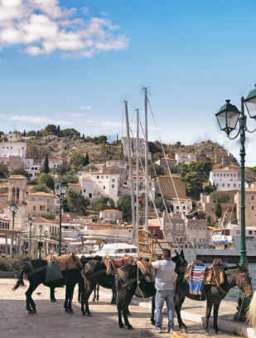
Teacher: Harry, why is Hydra quiet?
Harry: Because there isn’t much traffic there, and there aren’t any industries.
Teacher: You could be right. Gina?
Gina: There can’t be much traffic. Hydra is very small.
George: I’m not sure, but Hydra has no other town or village, apart from the main port. This is the centre of the island. The rest of the island is dry and all rocks.
Teacher: You almost got the answer. No vehicles are allowed on the island.
The only means of transport are mules and donkeys. You can use your feet, of course,
if you like!
Nick: I don't like walking up steep roads.
Harry: It's very unusual for a place in Greece not to have any vehicles at all.
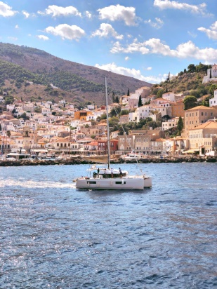
Teacher: You're right Harry, but this makes Hydra special. What about its history?
Does anybody know anything about Hydra's history?
Class: ……………………….
Teacher: Come on, say something.
Elena: All I know is that Hydra was important in the Greek War of Independence in 1821.
Teacher: Bravo, Elena!
Class: Wow!
Teacher: Well, the silent group at the back of the class will bring some information
on Hydra's history from the library. Their history teacher can help them.
They can also look at tourist guides on travelling in Greece.

(Words: 211)

Statements |  | A | B
 |  | TRUE | FALSE
 | Hydra is a very big island.
 | There is heavy traffic on the island during the summer.
 | Hydra’s main port is the centre of the island.
 | Vehicles are allowed on one part of the island.
 | The only means of transport are mules and donkeys.
 | Many Greek places are free of vehicles.
 | Hydra was important during the Greek War of Independence in 1821.
 | The group of students at the back of the class is very noisy.
 | The science teacher can help the students find specific information on Hydra.
 | Students can find information on Hydra in tourist guides.

ΘΕΜΑ 2^{α}. ΛΕΞΙΚΟΓΡΑΜΜΑΤΙΚΗ
Fill each gap in sentences 11-20 with the correct word from the box below (A-J). Use each word only once.
A. | transport | B. | industry | C. | allow | D. | vehicle | E. | traffic
F. | steep | G. | unusual | H. | port | I. | dry | J. | history

They don’t ____ pets in this hotel. We’ll have to ask a friend to look after Rocky during our trip.
Luckily, the driver of the ____ was not injured in the accident.
We got stuck in a ____ jam for several hours so we missed our flight to London.
It's a(n) ____ climb to the top of the mountain, but the view is worth it.
Bicycles are a cheap and efficient form of ____ around the city centre.
The tourist ____ has been booming in small Greek islands over the past few years.
I was actually on time, which is very ____ for me; I’m normally late in all my morning meetings.
What do you know about the ____ of graffiti? Where and when did it first appear?
We had a good view of all the ships coming into the ____.
These plants grow well in a ____ climate; they can survive with almost no water.

