ΘΕΜΑ 1. ΚΑΤΑΝΟΗΣΗ ΓΡΑΠΤΟΥ ΛΟΓΟΥ
Read the text and decide if each statement (1-10) is True (A) or False (B).
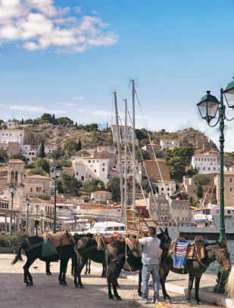
Teacher: Harry, why is Hydra so quiet?
Harry: Because there isn’t much traffic there, and there aren’t any industries.
Teacher: You could be right. Gina?
Gina: There can’t be much traffic. Hydra is a very small island.
George: I’m not sure, but Hydra has no other town or village, apart from the main port in the centre. The rest of the island is dry and all rocks.
Teacher: You almost got the answer. No vehicles are allowed on the island.
The only means of transport are mules and donkeys. You can use your feet, of course,
if you like!
Nick: I don't like walking up steep roads.
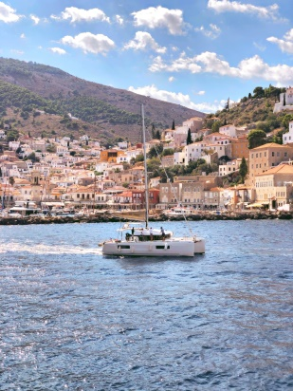
Harry: It's very unusual for a place not to have any vehicles at all.
Teacher: You're right Harry, but this makes Hydra a special island. What about its history?
Does anybody know anything about Hydra's history?
Class: ……………………….
Teacher: Come on, say something.
Elena: All I know is that Hydra was important in the Greek War of Independence in 1821.
Teacher: Bravo, Elena!
Class: Wow!
Teacher: Well, the silent group at the back of the class will bring some information
on Hydra's history from the library. Their history teacher can help them with this project. They can also look at tourist guides on travelling in Greece.
(Words: 213)

Statements |  | A | B
 |  | TRUE | FALSE
 | Hydra is a very quiet island.
 | There are a lot of industries around the port of Hydra.
 | Hydra is a dry and rocky island.
 | Vehicles are allowed on the island of Hydra.
 | People can move around the island on foot.
 | Nick likes walking up steep roads.
 | Hydra played an important role in the Greek War of Independence in 1821.
 | Students are asked to find information about the geography of Hydra in the library.
 | The geography teacher can help students complete their school project.
 | Students can find detailed information on Hydra in magazine articles.

ΘΕΜΑ 2^{α}. ΛΕΞΙΚΟΓΡΑΜΜΑΤΙΚΗ
Match each of the phrases below (11-20) with a word from the box that has a similar meaning (A-J). Use each word only once.
A. | transport | B. | industry | C. | allow | D. | vehicle | E. | traffic
F. | steep | G. | unusual | H. | port | I. | dry | J. | war

11. | With no water in it.
12. | The work involved in making things or producing goods in factories.
13. | A protected area of water where ships can load or unload goods or passengers.
14. | The movement of buses, cars, bicycles, etc. on the roads of towns or cities.
15. | To let somebody do something.
16. | Different from what is normal or happens very often.
17. | A period of fighting between countries or states.
18. | A road, hill, etc. that rises or falls sharply.
19. | A machine with wheels such as a car, truck, etc. that carries things, people, animals from one place to another.
20. | The activity of moving people or goods from one place to another by car, bus, train, etc.

