ΘΕΜΑ 1. ΚΑΤΑΝΟΗΣΗ ΓΡΑΠΤΟΥ ΛΟΓΟΥ
Read the text and decide if each statement (1-10) is True (A) or False (B).
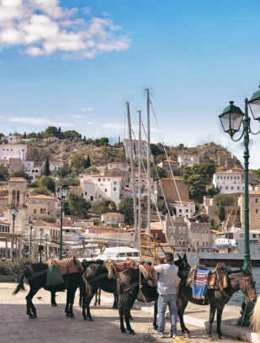
Teacher: Harry, why is Hydra quiet?
Harry: Because there isn’t much traffic there, and there aren’t any industries.
Teacher: You could be right. Gina?
Gina: There can’t be much traffic. Hydra is very small.
George: I’m not sure, but Hydra has no other town or village, apart from the main port that is in the centre of the island. The rest of the island is dry and all rocks.
Teacher: You almost got the answer. No vehicles are allowed on the island.
The only means of transport are mules and donkeys. You can use your feet, of course,
if you like!
Nick: I don't like walking up steep roads.
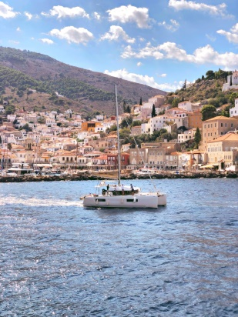
Harry: It's very unusual for a place not to have any vehicles at all.
Teacher: You're right Harry, but this makes Hydra such a special island. What about its history?
Does anybody know anything about Hydra's history?
Class: ……………………….
Teacher: Come on, say something.
Elena: All I know is that Hydra was important in the Greek War of Independence in 1821.
Teacher: Bravo, Elena!
Class: Wow!
Teacher: Well, the silent group at the back of the class will bring some information
on Hydra's history from the library. Their history teacher can help them.
They can also look at tourist guides on travelling around Greece.
(Words: 210)

Statements |  | A | B
 |  | TRUE | FALSE
 | Hydra is a very small island.
 | There is a lot of traffic in Hydra during the summer time.
 | Hydra is full of small villages around its main port.
 | Vehicles are not allowed on the island of Hydra.
 | The only way to move around Hydra is by riding a bicycle.
 | Hydra is quite similar to other Greek islands.
 | Hydra did not participate at all in the Greek War of Independence in 1821.
 | The group of students at the back of the class is quiet.
 | The history teacher can help the students find more specific information on Hydra.
 | Students can find more information on Hydra’s history in the library.

ΘΕΜΑ 2^{α}. ΛΕΞΙΚΟΓΡΑΜΜΑΤΙΚΗ
Match each of the phrases below (11-20) with a word from the box that has a similar meaning (A-J). Use each word only once.

A. | library | B. | industry | C. | allow | D. | vehicle | E. | traffic
F. | steep | G. | unusual | H. | port | I. | dry | J. | silent

11. | A place with little or no rain.
12. | All the people and activities involved in making specific products in factories.
13. | An area where ships load and unload goods or passengers.
14. | The movement of vehicles along the roads in a particular area.
15. | Give someone permission to do something.
16. | Not common or ordinary.
17. | Making no sound at all, being completely quiet.
18. | A place that rises or falls sharply.
19. | A machine with an engine that carries people or things from one place to another.
20. | A building where books are kept for people to read or borrow.

