ΘΕΜΑ 1. ΚΑΤΑΝΟΗΣΗ ΓΡΑΠΤΟΥ ΛΟΓΟΥ
Read the text and decide if each statement (1-10) is True (A), False (B) or Not Mentioned (C).

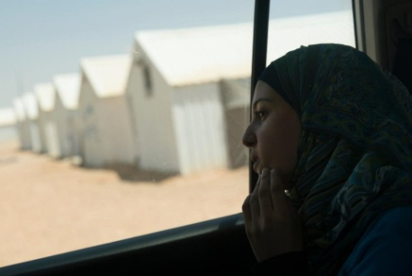
A passionate defender of girls and young women’s access to education in Jordan’s refugee camps, Muzon has been honoured as Syria’s answer to Malala. When Muzon’s family escaped the war in Syria in early 2013, they briefly considered leaving her behind. The bright 14-year-old had been studying hard all year for her grade-nine school exams, which were just a month away, and her aunt insisted on her staying to continue her studies. In the end, her father decided the risks were too great, and so the girl left with him and her siblings across the border to Jordan.
Education has always played a big part in Muzon’s life. Both of her parents were teachers back in Syria’s southern area of Dara’a, and her aunt and uncle were head teachers at local schools. “I did not need them to tell me that education is important. I always just felt it.” she explains. “Our house was built by an engineer. When I was sick I went to a doctor. Education is everything in life.”
Now 17, not only has she continued her studies in Jordan, but she has also become a forceful and increasingly high-profile supporter for education among Syrian refugees, especially young women and girls. Her campaigning is strongly compared to that of Malala, whom Muzon has met several times and considers a personal friend. “She taught me that no matter what obstacles I might face in life, they can be overcome.” Before the crisis began, Muzon led a normal, middle-class life among friendly neighbours and relatives. The family’s main home in Izra was close to a military base that regularly came under attack, leaving the family trapped in the crossfire. Unable to endure the fighting any longer, they made their way to Jordan and settled initially in Za’atari refugee camp.
(Words: 300)

Statements |  | A | B | C
 |  | TRUE | FALSE | NOT MENTIONED
 | Muzon helps young women find a decent job outside the refugee camp.
 | Muzon’s father left her behind when they decided to escape the Syrian war.
 | Muzon had always been a hard-working student at school.
 | Muzon’s father never considered leaving his daughter behind.
 | Both Muzon’s parents were highly qualified health workers.
 | Muzon’s father built their house in Izra by himself.
 | Muzon helps Syrian girls and women to continue their education.
 | Malala has won a Nobel Prize for her education campaigns.
 | In Syria Muzon lived in a luxurious house near the borders.
 | The family left Syria because they couldn’t stand the military conflicts.

ΘΕΜΑ 2^{α}. ΛΕΞΙΚΟΓΡΑΜΜΑΤΙΚΗ
Fill each gap in sentences 11-20 with the correct word from the box below (A-J). Use each word only once.
A. | settle | B. | passionate | C. | increasingly | D. | campaigned | E. | friendly
F. | border | G. | education | H. | defend | I. | regularly | J. | insisted

The local people have successfully ____ against a new, giant hotel being built next to their lovely beach.
We travelled through the longest motorway tunnel in Italy, which is located under the Alps, on the ____ with France.
He works as a war correspondent and covers stories first-hand from any war zone but he also writes ____for the ‘International Affairs’ magazine.

Finland is a country which places great importance on children’s ____; thus, serious work is done to ensure that every child has access to it from an early age.
I’m sure there won’t be any lawyer who would agree to ____ such a notorious criminal.
He was finding it ____ more and more difficult to remember everyday things so he decided to seek professional help.
A group of students from our school took part in a global campaign and gave a really ____ speech on the main causes of the refugee crisis around the world nowadays.
The teacher is ____ with all her students, but a bit strict at the same time.
After wandering for a couple of years all around Europe, Jane was offered a highly-paid job and so she finally decided to ____ in Italy.
The demonstrators blocked the entrance of the town hall and ____ on a meeting with the mayor.

