ΘΕΜΑ 1. ΚΑΤΑΝΟΗΣΗ ΓΡΑΠΤΟΥ ΛΟΓΟΥ
Read the text and choose the correct option (A, B or C) for items 1-10.
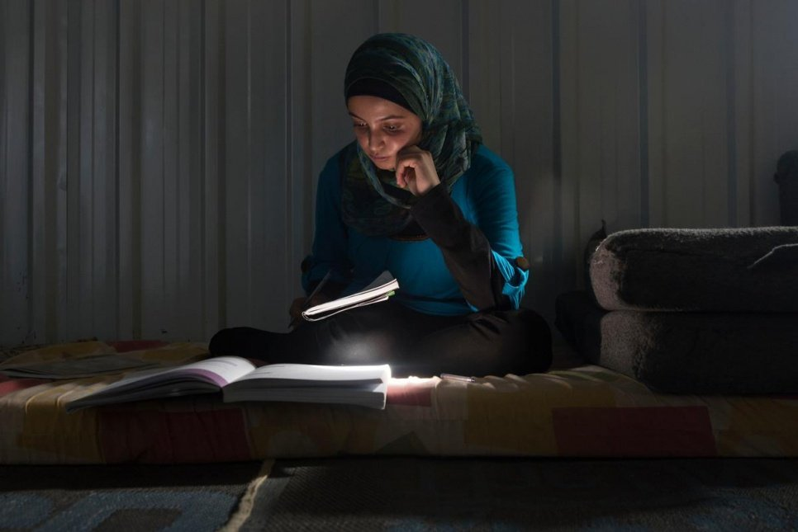
Muzon, a passionate supporter of girls and young women’s access to education in Jordan’s refugee’s camps, has been regarded as Syria’s answer to Malala.
When Muzon’s family escaped the war in Syria in 2013, they considered leaving her behind. The bright 14-year-old had been studying hard all year for her grade-nine school exams and her aunt encouraged the family to let her stay and continue her education. However, her father decided that the risks were too great and that Muzon could make up for lost schooling, but if she lost her life there would be no way to make up for that. So the girl fled with him and her siblings to Jordan’s Azraq refugee camp.
Education has always played a big part in Muzon’s life. Both of her parents were teachers back in Syria’s southern area of Dara’a, and her aunt and uncle were head teachers at local schools. “I didn’t need them to tell me that education is important. I always just felt it.” she explains. “Our house was built by an engineer. When I was sick I went to a doctor. Education is everything in life.”
Now 17, not only has she continued her studies in Jordan, but she has become a powerful and high-profile supporter for education among Syrian refugees, especially young women and girls. Her campaigning shares a number of similarities to that of Malala, Pakistan’s Nobel Prize-winning education campaigner, whom Muzon considers a personal friend. “She taught me that no matter what obstacles I face in life, they can be overcome.” The family’s main home in Izra was close to a military base that regularly came under attack, leaving them trapped in the crossfire. Unable to tolerate the fighting any longer, they made their way to Jordan and settled initially in Za’atari refugee camp.
(Words: 300)

1. The purpose of the text is to
 | A. |  | inform people about the refugee crisis. |  |  | B. | encourage people to provide help to refugees. | C. | tell the story of a refugee girl who fights for education.
2. Who would be most interested in reading this text?
 | A. |  | University students |  |  | B. | The general public | C. | Head teachers
3. When Muzon’s family decided to leave Syria,
 | A. |  | Muzon didn’t want to follow them. |  |  | B. | a relative suggested her staying behind. | C. | they never thought of taking Muzon with them.
4. According to her father, Muzon would
 | A. |  | never be able to catch up with her lost lessons. |  |  | B. | have to stop schooling if she left Syria. | C. | lose everything if she lost her life during the Syrian war.
5. According to the text, Muzon
 | A. |  | followed her family to a new country. |  |  | B. | settled in a refugee camp in Syria. | C. | was allowed to stay in Syria with her aunt.
6. Muzon’s parents
 | A. |  | taught her the importance of taking exams. |  |  | B. | worked for education in southern Syria. | C. | worked as head teachers at local schools in Jordan.
7. Muzon says that her house was built by an engineer in order to show
 | A. |  | the difficulties they faced when building their house. |  |  | B. | the significance of education in her family’s life. | C. | how necessary an engineer is for building a house.
8. Malala and Muzon have
 |  | A. |  |  | never met each other. | B. | both fought for education. | C. | both won a Nobel Prize.
9. In the text, the underlined word “powerful” is closest in meaning to
 |  | A. |  |  | passionate | B. | sensitive | C. | violent
10. Muzon’s family left Syria because
 |  | A. |  | their house was too small. |  | B. | they lived on a military base. | C. | they wanted a safer life.

ΘΕΜΑ 2^{α}. ΛΕΞΙΚΟΓΡΑΜΜΑΤΙΚΗ
Match each underlined word/phrase in the sentences below (11-20) with a word from the box that has a similar meaning (A-J). Use each word only once.
A. | powerful | B. | initially | C. | importance | D. | campaigning | E. | education
F. | unable | G. | tolerate | H. | obstacles | I. | encourage | J. | support

She was really shocked when she heard the tragic news of her closest friend’s death in a car accident, so she remained silent, not in a position to say a word.
Instead of fighting against overtourism, local communities should think of ways to make it safer and promote eco-tourism
Our teacher would never accept any form of disrespectful behaviour in his classes.
Despite the great number of difficulties I had to face as a university student, including the lack of time needed to study while having a part-time job at the same time, I finally managed to graduate.
Teachers should use creative teaching methods that can help children to think for themselves.
Sara has to work hard to earn a living for her family but she is determined to give her kids a better chance in life.
Wegener's scientific theory was originally rejected by other scientists of his time but it became really influential in the long run.
He emphasized the significance of all employees following the safety procedures to ensure workplace safety.
Throughout his schooling, he used to feel that going to school was quite useless. It took him quite some time to realise its importance.
This new invention enables handicapped people to easily communicate with their friends. In fact, it is considered a very effective method of online communication.

