ΘΕΜΑ 1. ΚΑΤΑΝΟΗΣΗ ΓΡΑΠΤΟΥ ΛΟΓΟΥ
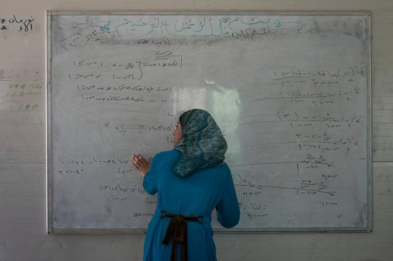
Read the text and choose the correct option (A, B or C) for items 1-10.
A passionate defender of the education of girls and young women in Jordan’s refugee camps, Muzon has been honoured as Syria’s answer to Malala. When Muzon’s family escaped the war in Syria in early 2013, they briefly considered leaving her behind. The bright 14-year-old had been studying hard all year for her grade-nine school exams, which were just a month away, and her aunt insisted on her staying to continue her studies.
In the end, her father decided the risks were too great, and so the girl left with him and her siblings across the border to Jordan. However, education has always played a big part in Muzon’s life. Both of her parents were teachers back in Syria’s southern Dara’a province, and her aunt and uncle were head teachers at local schools. “I didn’t need them to tell me that education is important. I always just felt it,” she explains. “Our house was built by an engineer. When I was sick I went to a doctor. Education is everything in life.”
Now 17, not only has she continued her studies in Jordan, but she has also become a forceful and increasingly high-profile supporter for education among Syrian refugees, especially young women and girls. Her campaigning is strongly compared to Malala’s, Pakistan’s Nobel Prize-winning education defender, whom Muzon has met several times and considers a personal friend. “She taught me that no matter what obstacles I face in life, they can be overcome.” Before the crisis began, Muzon led a normal, middle-class life among friendly neighbours and relatives. The family’s main home in Izra was close to a military base that regularly came under attack, leaving the family trapped in the crossfire. Unable to endure the situation any longer, they made their way to Jordan and settled in Za’atari refugee camp.
(Words: 300)

1. The text talks about
 | A. | a Syrian family that supported refugees in Jordan. | B. | a young girl who stayed in Syria to continue school. | C. | a Syrian girl who received education in a refugee camp.
2. Who would be most interested in reading this text?
 | A. | Young refugee mothers. | B. | The general public. | C. | War reporters.
3. Muzon’s family thought of leaving her behind because
 | A. | her aunt didn’t let her go. | B. | Muzon insisted on staying. | C. | she could continue her classes.
4. For Muzon education
 | A. | has always been of great importance to her. | B. | was necessary for her to get married. | C. | was not appreciated by her family members.
5. According to the text, Muzon
 | A. | wants to become a teacher in a refugee camp. | B. | fights for the education of female Syrian refugees. | C. | wants to go back to her home in Izra.
6. The text suggests that Malala and Muzon have
 | A. | both won a Nobel Prize. | B. | never met each other. | C. | been fighting for the same cause.
7. Malala helped Muzon realize that she
 | A. | can deal with any problem. | B. | cannot overcome all obstacles. | C. | should make more friends.
8. When Muzon was in Syria she lived
 | A. | in a remote area. | B. | a happy, ordinary life. | C. | on a military base.
9. In the text, the underlined word “endure” is closest in meaning to
 | A. | change | B. | stand | C. | avoid
10. According to the text, Muzon
 | A. | is living in a refugee camp. | B. | will go back to Syria soon. | C. | will move to a refugee camp soon.

ΘΕΜΑ 2^{α}. ΛΕΞΙΚΟΓΡΑΜΜΑΤΙΚΗ
Fill each gap in sentences 11-20 with the correct word from the box below (A-J). Use each word only once.
A. | briefly | B. | insisted | C. | prize | D. | forceful | E. | education
F. | refugee | G. | passionate | H. | defend | I. | border | J. | endure

The longest motorway tunnel in Italy is located under the Alps, near the ____ with France.
Mary has a rather ____ personality which will serve her well if she ever decides to get involved in politics.
The protesters blocked the entrance of the building and ____ on arranging a meeting with the Minister.
The students who took part in the essay competition wrote a(n) ____ article on how to help protect the endangered animals of their region.
The government decided to organise a special program for ____ children and their families who had managed to escape the Syrian war.
The accused man hired a well-known lawyer to ____ him in court; he wanted to prove his innocence at all costs.
In this short essay, I will ____ mention some of the advantages and disadvantages of owning an electric car.
She felt extremely flattered when she was told that she would be awarded first ____ in the story writing competition.
After the accident, the injured athlete had to ____ three painful operations on her broken leg before getting back on the field.
Due to his health problem, as a child he received most of his ____ at home; so it was really difficult for him to make any close friends.

