ΘΕΜΑ 1. ΚΑΤΑΝΟΗΣΗ ΓΡΑΠΤΟΥ ΛΟΓΟΥ
Read the text and decide if each statement (1-10) is True (A), False (B) or Not Mentioned (C).

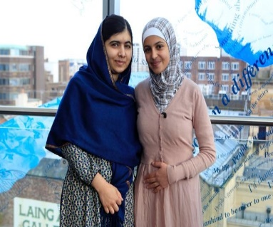
As Muzon continued her schooling in the refugee camp, she noticed that many of her fellow pupils stopped attending classes, often girls around her own age. She heard about one girl who had dropped out and was trying to sell her schoolbooks. Muzon sought her out and convinced her to change her mind. A passionate supporter of education was born.
She says that she has encountered strong objections along the way: “some people refuse to listen from the start. They think, ‘Why should we listen to her? She’s my children’s age.’ But I don’t let it discourage me. The opposite, in fact; it makes me want to talk to more people and try again and again.”
Her friendship with Malala has provided Muzon with a role model for her movement and has also raised her profile within the camp and beyond. She has met several other high-profile visitors to Azraq and understands the importance of spreading her message through them to a wider audience.
“As an individual, I can convince people I meet to go to school but I cannot build the schools or provide the teachers,” she admits. “We need the help of the international community to do that, so I need to get the message out to those who have the resources to help.”
When I express admiration at what she has achieved despite her age and difficult circumstances, she brushes off the compliment. “Of course, I have tried to turn this experience into a positive one,” she says. “Being a refugee doesn’t have to ruin your life. Many successful people have gone through hard times.”
Education has given Muzon’s life in the refugee camp a newfound purpose, and her simple message to the world is that the same can and should be true for every young refugee.
(300 words)

Statements |  | A | B | C
 |  | TRUE | FALSE | NOT MENTIONED
 | Muzon didn’t know that many of her fellow pupils had dropped out of school.
 | Muzon persuaded a pupil who had dropped out to continue school.
 | Muzon spoke for education enthusiastically inside and outside the camp.
 | Some people refused to listen to Muzon because of her young age.
 | Malala and Muzon come from the same country.
 | Muzon thinks that sharing her ideas with as many people as possible is useless.
 | Muzon thinks that people who have the means could support education in refugee camps.
 | Muzon’s ideas might put young female refugees at risk.
 | Muzon has tried to turn being a refugee into a positive experience.
 | Muzon has founded an organization to promote education in refugee camps.

ΘΕΜΑ 2^{α}. ΛΕΞΙΚΟΓΡΑΜΜΑΤΙΚΗ
Use the correct form of the following words (A-Κ) to complete the gaps (11-20) as in the example.
A. | friendship | B. | child | C. | true | D. | successful | E. | express | F. | understand
G. | think | H. | opposite | I. | build | J. | education | K. | achieve

EXAMPLE | Every time he thought of the jokes he made at school, he had a funny EXPRESSION on his face.
 | Following a long discussion on the proposed business plan, seven members of the committee ____ to it while three members were in favor.
 | She is a sociable, kind young woman eager to share her ____ and ideas with her colleagues.
 | The construction of this giant hotel lasted three years and offered employment to over 500 ____ who worked really hard to have it completed just in time for the summer holidays.
 | If we want to protect our planet, we should all try to use products that are ____ to the environment.
 | Winning the Olympic gold medal despite the injuries she suffered last year has been a great ____ of hers; she never got discouraged, despite the difficulties.
 | The piece of advice her parents kept giving her when she was young was: “You won’t ____ in anything unless you try hard”.
 | Parents should buy their children ____ toys that can help them learn new things while having fun at the same time.
 | Please don't ____ me! I never said I cannot complete the project; I just need more time to check everything out before its submission.
 | There are many photos around the house of me as a child. There is one photo in particular of me riding my new red bike that always makes me think of how happy my ____actually was.
 | To tell you the ____, I never expected them to admit their mistake. They have always been so arrogant and selfish!

